# **Linux Module1 Exercise**

**1. Creating users in Linux:**

* Which command is used to create a new user in Linux?
* Useradd command is used to create a new user in Linux.
* What is the syntax for creating a user using the useradd command?

SYNTAX:

* Useradd <username>

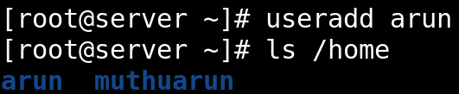

* Can you create a user with specific user ID (UID) and group ID (GID) using the useradd command? If yes, how?
* Yes, we can create a user with specific uid and gid using the useradd command.
* useradd -u <uid num> -g <gid num> <name>

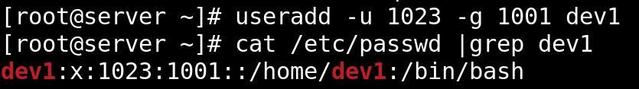

* How can you set an initial password for a newly created user?
* passwd <username>

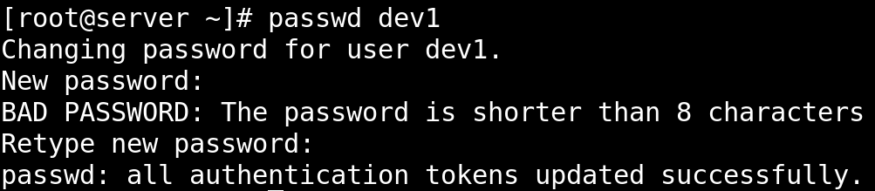

* What happens if you try to create a user with a username that already exists on the system?
* If we try to create a user with a same username that already exists on the system, it shows the user “username” already exists.

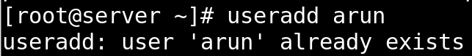

* Is it possible to create a user without a home directory? If yes, how?
* Yes, we can create a user without a home directory.
* Using the command useradd -M <name>.
* -M option with the command creates the user without the home directory.

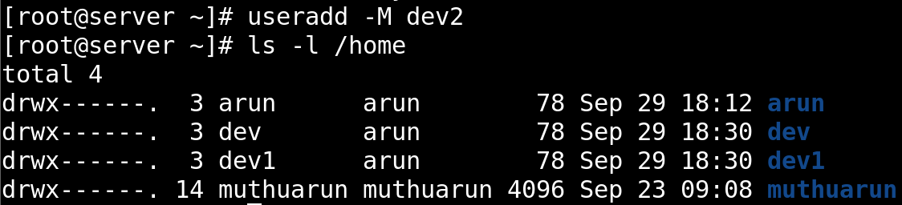

* How can you specify the shell for a user during creation?

SYNTAX:

* Useradd -s /bin/bash <username>

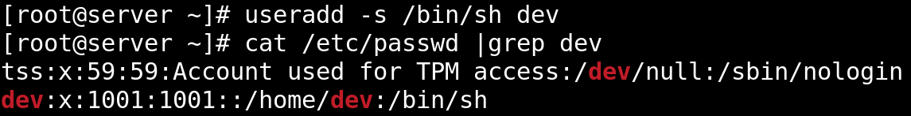

* Can you create a user with additional supplementary groups using the useradd command? If yes, how?

SYNTAX:

* Useradd -G <groupname> <username>

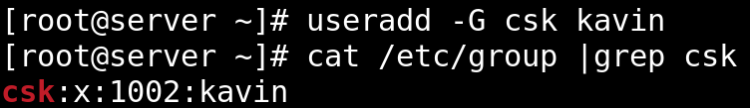

* How can you verify that a user has been successfully created?
* By using a /etc/passwd command.
* It shows the information about User Details.

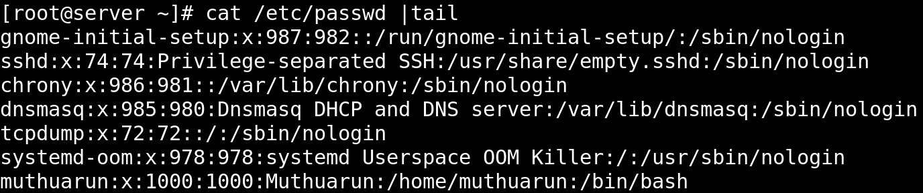

* Is there a way to create a user with a specific expiration date? If yes, how?
* Yes, we can create a user with a specific expiration data.
* useradd -e yyyy/mm/dd <user name>

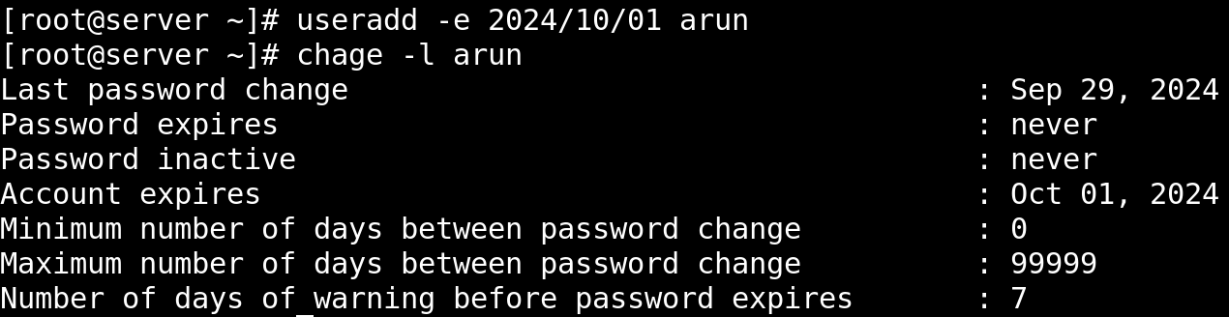

**2. cat command in Linux:**

* What is the purpose of the cat command in Linux?
* It is used to view the content of the File.
* It is also used to create a File.
* How do I use the cat command to display the contents of a file on the terminal?

SYNTAX:

* Cat <filename>

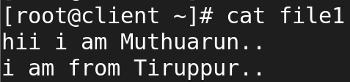

* Can cat display the contents of multiple files at once?
* Yes, Cat command display the content of multiple files.

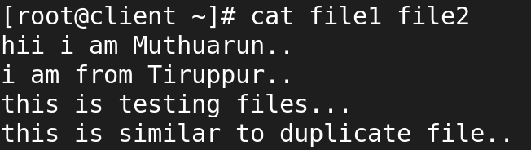

* What are some options available with the cat command, and how do I use them?

-b 🡪 Creates a numbered list with non-blank lines.

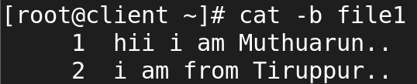

-e 🡪 Shows non-printing characters and ends lines with $.

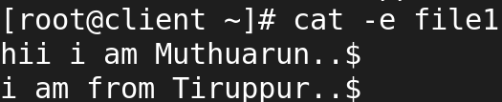

* How can I create a new file using the cat command?

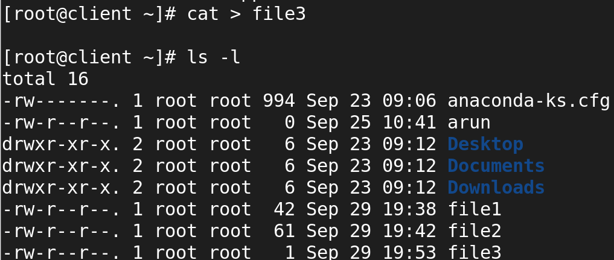

* Is it possible to concatenate multiple files using cat? If yes, how?
* Yes, it is possible to Concatenate multiple files by using cat command.



* How does the cat command handle binary files?

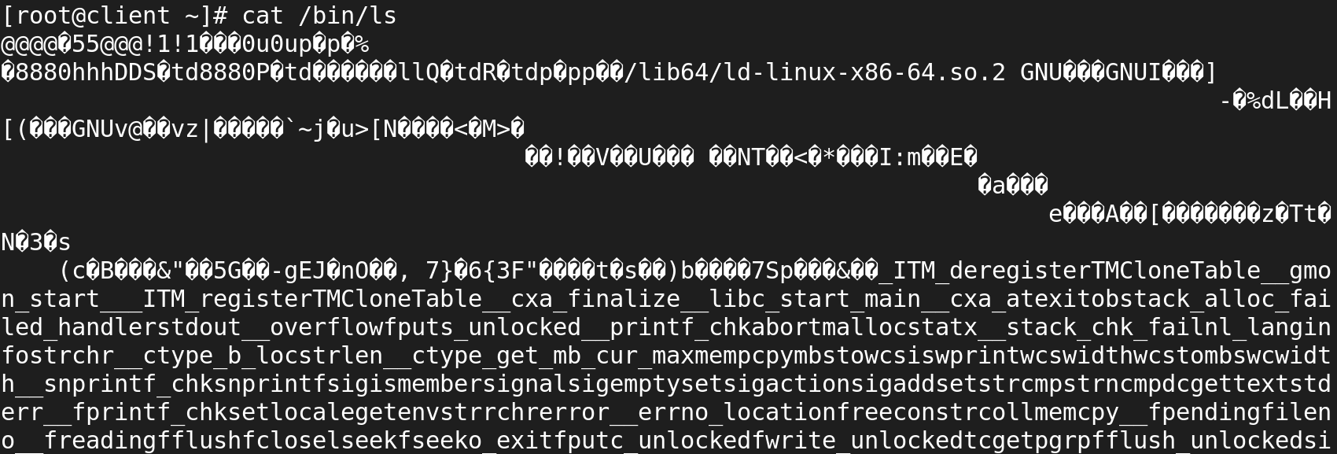

* Can I number the lines while displaying the contents of a file with cat?

SYNTAX:

* Cat -n <filename>

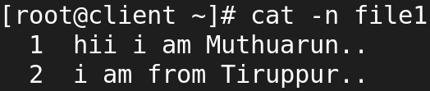

* How do I suppress the display of trailing whitespace in cat output?
* By using -s option to suppress the display of trailing whitespace in cat command.

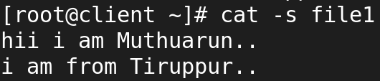

* Can I use cat to append the contents of one file to another?

SYNTAX:

Cat file1 >> file2

## 

* Is it possible to create a copy of a file using the cat command?
* Yes, it is possible to copy of a file using the cat command.

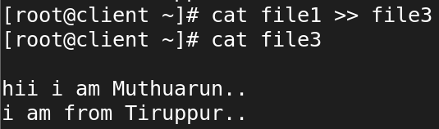

* How can I use cat to display non-printing characters like tabs and newlines as visible characters?

SYNTAX:

Cat -A <filename>

-A 🡪 -vET

* -v 🡪 Displays non-printing characters (except for tabs and newlines).
* -E 🡪 Displays $ at the end of each line to show newlines.
* -T 🡪 Displays tabs as ^I

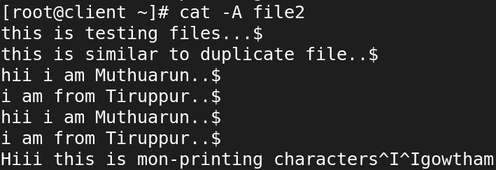

* What happens if I use cat with multiple files, but some of them do not exist?
* cat will display an error message for each non-existent file, but it will still concatenate and display the contents of the files that do exist.

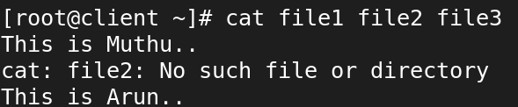

* Can cat be used to view the contents of remote files over SSH?
* Yes, you can use cat to view the contents of remote files over SSH by using it in combination with the ssh command.
* This allows you to execute cat on a remote machine and display the contents of a file on your local terminal.

SYNTAX:

* Ssh root@192.168.45.132 ‘cat /root/file1’

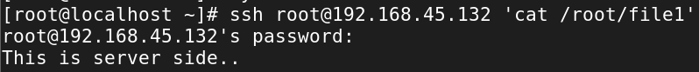

* How does the cat command handle files with very long lines?
* We can view the very long lines by scrolling otherwise we can use tail less command

**3. “ls” command in Linux:**

* What is the purpose of the ls command in Linux?
* The ls command in Linux is used to list the contents of a directory.
* It displays the files and directories within the specified directory or the current directory if no path is provided.
* The command can also be used with various options to show additional details, such as file permissions, ownership, size, and modification date.
* How do I use the ls command to list files and directories in the current directory?
* ls command is used to list files and directories in the current directory.



* Can ls display file and directory details, such as permissions, owner, size, and modification date?
* ls -l: Lists files in long format, showing details like permissions, number of links, owner, group, size, and timestamp.

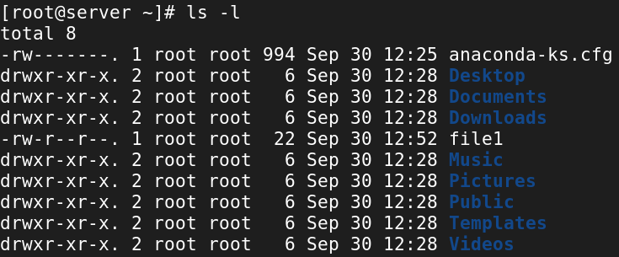

* How can I list files and directories in a specific directory other than the current one?
* To list files and directories in a specific directory other than the current one, you can use the ls command, followed by the path of the directory.

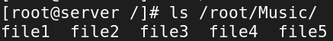

* What are some common options that can be used with the ls command, and how do I use them?

**-l 🡪** Displays detailed information.

**-a 🡪** Lists all files, including hidden files.

**-h 🡪** Shows file sizes in human-readable format.

**-R 🡪** Lists all files and subdirectories recursively.

**-t 🡪** Sorts files by modification time.

**-s** 🡪 Reverses the order of sorting.

**-d** 🡪 Lists directories themselves rather than their contents.

* How can I make ls show hidden files and directories?
* **ls -la** Command is used to show hidden files and directories.

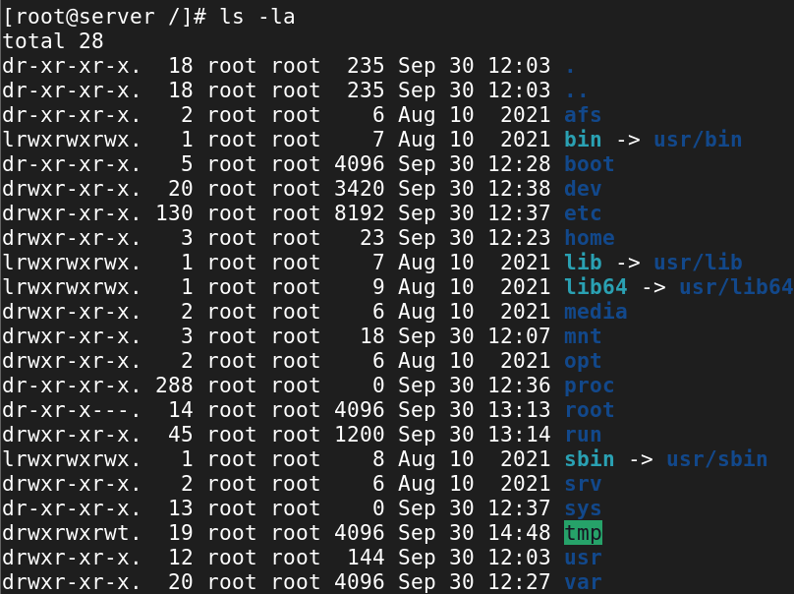

* Is it possible to list files and directories in a long format with human-readable file sizes?
* **ls -lh** command is used to list file and directories in a long format with human readable file sizes.

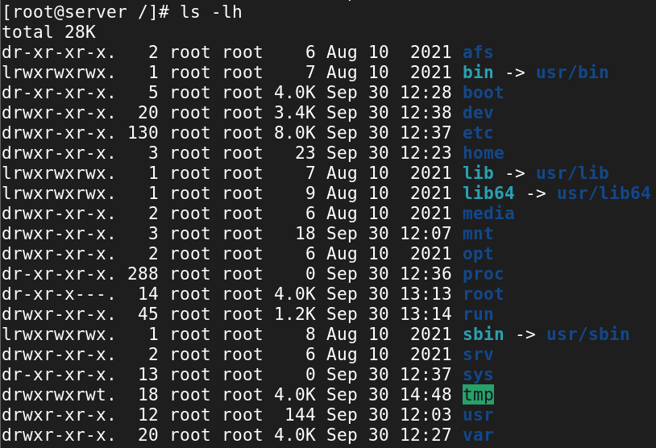

* How do I sort the ls output by different criteria, such as name, size, or modification time?

**ls** 🡪 command sorts files and directories alphabetically by name.

**-S** 🡪 sort files by size in descending order.

**-t** 🡪 sort by modification time.

**-u** 🡪 sort by the last access time of the files.

**-c** 🡪 sort by the last status change time.

**-X** 🡪 option to sort files alphabetically by their extensions

**-r** 🡪 To reverse the order.

**-sr** 🡪 to sort by size and then reverse the order:

**-la 🡪** to long list with hidden files.

**-ltr 🡪** long list with time reverse.

* Can ls display files and directories with color-coded output?
* ls --color



* How can I recursively list files and directories within sub-directories?
* **ls -lR** is the command is used to list files and directories within sub-directories recursively.

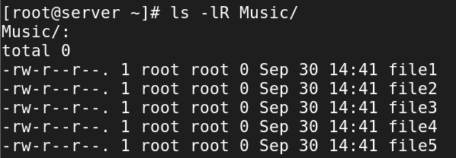

* What is the difference between ls and ls -l in terms of the information they display?

**ls:**

* Displays only filenames and directory names.
* Best for a quick overview of contents.

**ls -l:**

* Shows detailed information for each file, such as permissions, owner, size, and modification date.
* Useful for inspecting file attributes and permissions in detail.
* How can I use ls to find files that match a specific pattern or extension?
* To list all files with the .txt extension.
* To find all files that start with file.



* Can ls display file sizes in units other than bytes, such as kilobytes or megabytes?
* **ls -lh** command is used to display the sizes in human readable format.

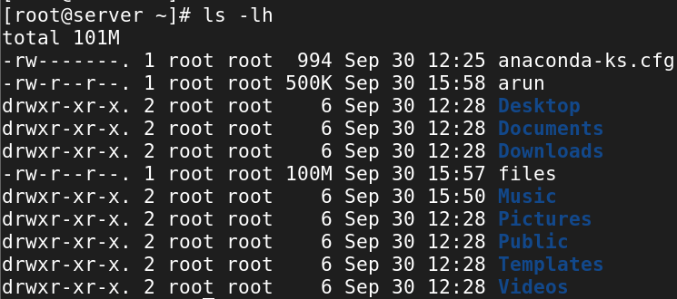

* How do I use ls to list only directories, excluding regular files?
* ls -d command is used to list only directories.



* What happens if I use ls with a directory that I don't have permission to access?
* If you use the ls command on a directory that you do not have permission to access, you will receive an error message indicating that you do not have the necessary permissions.
* The behaviour can vary slightly depending on your user permissions and the specific options used with ls.

**4. Creating directories in Linux:**

* Which command is used to create a new directory in Linux?
* mkdir command is used to create a new directory in Linux.
* mkdir expands for make a directory.
* What is the syntax for creating a directory using the mkdir command?

SYNTAX:

* mkdir <directory name>

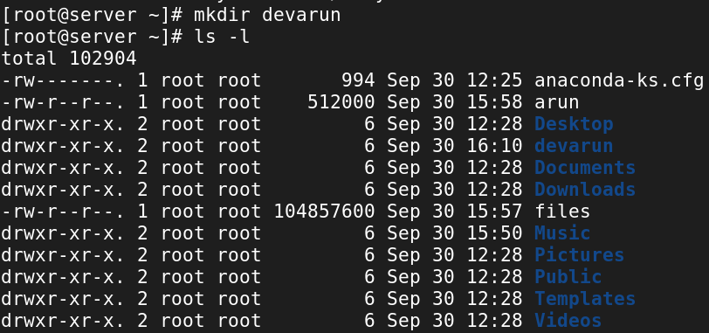

* Can you create multiple directories at once using the mkdir command? If yes, how?
* Yes, we can create multiple directories at once using the mkdir command.

SYNTAX:

mkdir <directoryname1>..<directoryname n>

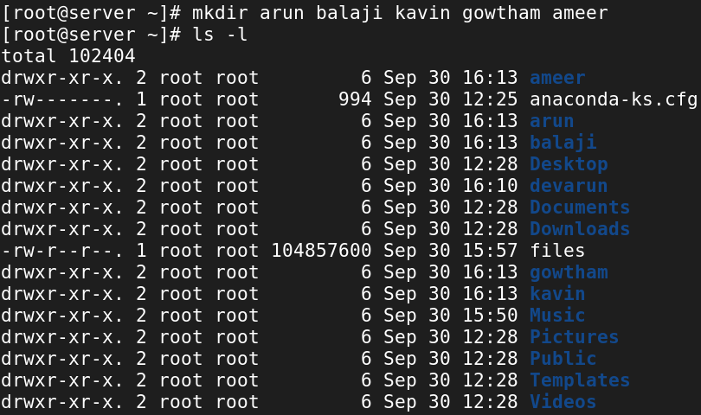

* How can you specify the full path for creating a directory in a specific location?

**Use Absolute Path**:

* An absolute path starts from the root directory (/).

**Example:**

mkdir /home/muthuarun/dev

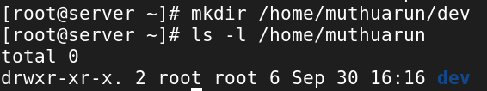

**Use Relative Path**:

* If you're in a specific directory and want to create a directory relative to your current location:

**Example:**

mkdir collection/car/bmw

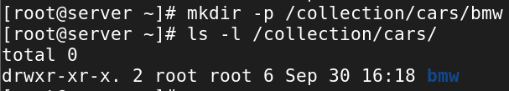

* What happens if you try to create a directory with a name that already exists in the current location?

**Error Message**:

* You will receive an error message indicating that the directory cannot be created because it already exists.
* mkdir: cannot create directory 'directory_name': File exists



**No Changes Made**:

* The existing directory will remain unchanged, and no new directory will be created.

**No Overwriting**:

* The mkdir command does not overwrite existing directories.
* If a directory with the same name exists, the command will simply fail without modifying or deleting the existing directory.
* Is it possible to create a directory with a space in its name? If yes, how?
* Yes, it is possible to create a directory with a space in its name.
* use single quotes (') or double quotes (") around the directory name to include spaces.

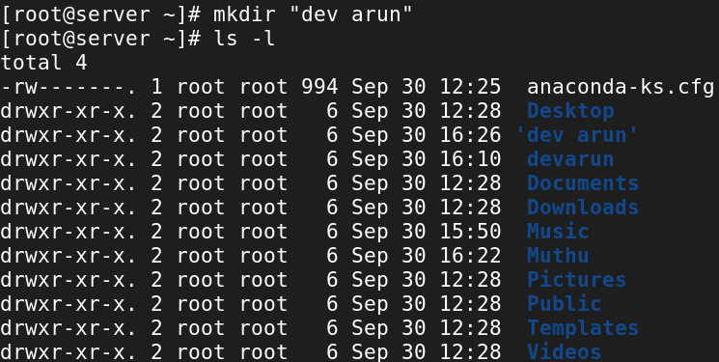

* backslash (\) to escape the space character in the directory name.



* How can you verify that a directory has been successfully created?
* By listing, we can see directory is created or not.
* Is there a way to create directories with specific permissions using the mkdir command?
* mkdir -m <permissions> <directory_name> to create directories with specific permissions.

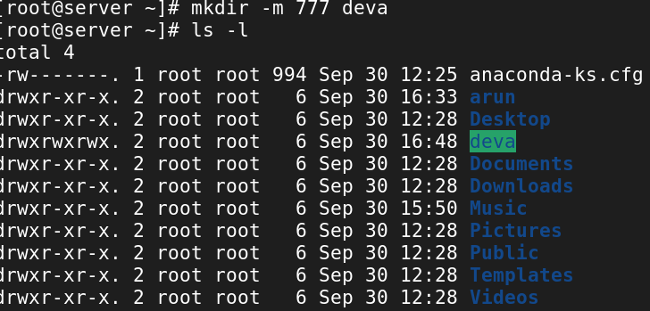

* How can you create nested directories (directories within directories) using the mkdir command?
* mkdir -p /path/to/nested/directories to create nested directories.
* The -p option ensures that any necessary parent directories are created automatically if they do not already exist.

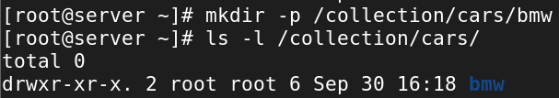

* Can you create a directory with a relative path instead of an absolute path? If yes, how?
* You can create directories using relative paths by specifying the directory name or using.. to refer to parent directories.
* Use mkdir my_directory for a simple directory, or mkdir -p my_folder/child_folder for nested directories.
* Chaining .. allows you to navigate up multiple levels in the directory structure.



**5. copy (cp), move (mv), and remove (rm) commands for files and directories in Linux:**

**Copy (cp):**

* How do I copy a file to a different directory using the cp command?
* cp <source_file> <destination_directory/> to copy a file.

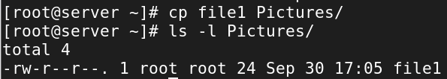

* Can I preserve the original file permissions when copying with cp?
* cp -p <source_file> <destination_file> to copy a file while preserving its original permissions.

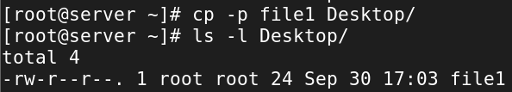

* How can I copy multiple files at once using the cp command?

SYNTAX:

* cp <source_file1>..<source_filen> <destination_file>

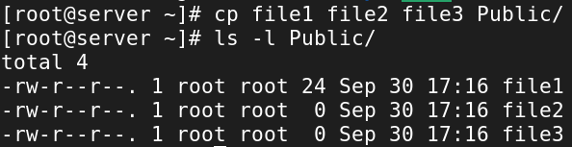

* Is it possible to overwrite an existing file when copying with cp?
* Overwrite an existing file by using the cp command followed by the source file and the destination file.



* How can I copy a directory and its contents using cp?
* cp -r <source_file> <destination_file> is used to copy a directory and its contents using cp.

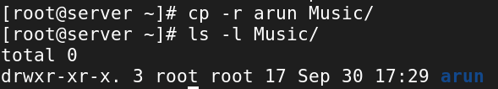

**Move (mv):**

* How do I move a file to a different directory using the mv command?
* By using **mv** command to move a file to a different directory using the mv command.

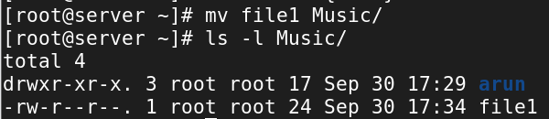

* Can I rename a file while moving it with the mv command?
* Yes, you can rename a file while moving it using the mv command in Linux.

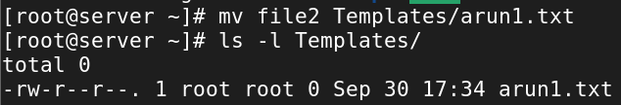

* What happens if I move a file to a directory where a file with the same name already exists?

**Overwrite Behavior**:

* The existing file with the same name will be overwritten by default.

**No Prompt**:

* The command does not prompt for confirmation unless you use the -i option.

**Use -i for Safety**:

* To avoid accidental overwriting, use mv -i to receive a confirmation prompt.
* How can I move multiple files at once using the mv command?
* Yes, you can move multiple files at once using the mv command.

**Syntax:**

* mv <source_file1>..<source_filen> <destination_file>

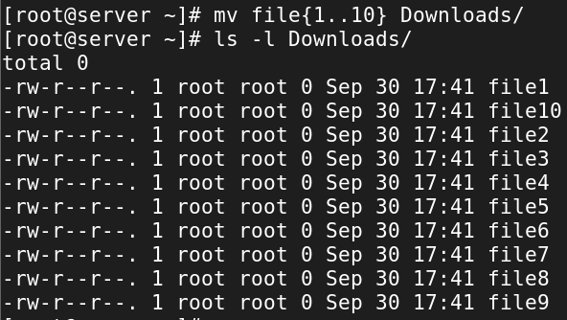

* Is it possible to move a directory and its contents using mv?
* Yes, it is possible to move a directory and its contents using mv.

Syntax:

* mv -r <source_file> <destination_file>

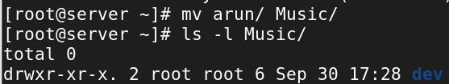

**Remove (rm):**

* How do I remove a file using the rm command?

Syntax:

* rm <file_name>

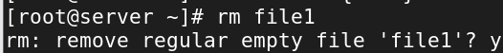

* Can I remove multiple files at once using the rm command?
* Yes, you can remove multiple files at once using the rm command.

Syntax:

* rm -r <file1>..<filen>

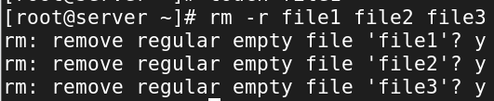

* How can I remove a directory and its contents using the rm command?

Syntax:

* rm -r <directory>
* -r 🡪 recursively remove the directory.

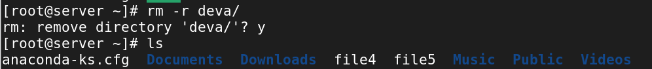

* What happens if I try to remove a file that is write-protected or has special permissions?
* You can delete write-protected files using rm, but you will need the appropriate permissions.
* If you lack permission or if the file has special attributes, you will receive an error message.
* You can use sudo to remove files for which you do not have sufficient permissions if you have superuser access.
* Is there a way to force the removal of files or directories using rm?
* Yes, there is a way to force the removal of files or directories using rm.

Syntax:

* rm -rf <file_name> or <directory_name>
* -r 🡪 recursively remove the files or directory.
* -f 🡪 Forcefully remove the files or directory.

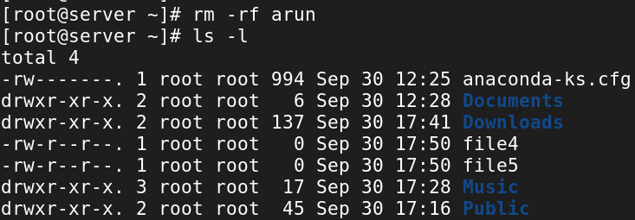

**6. File & Dir permissions**

* What are the three basic permissions for a file in Linux?

**Read (r)**: View the contents of the file.

**Write (w)**: Modify or delete the file.

**Execute (x)**: Run the file as a program or script.

* How are file permissions represented in the output of the ls -l command?

**Format**:

* The output begins with a ten-character string indicating file type and permissions.

**File Type**:

* First character:
  + -: Regular file
  + d: Directory
  + l: Symbolic link

**Owner Permissions**:

* Next three characters represent the owner’s permissions:
  + r: Read
  + w: Write
  + x: Execute
  + -: No permission

**Group Permissions**:

* Following three characters represent the group’s permissions.

**Others Permissions**:

* Last three characters represent permissions for others.

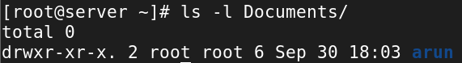

* What does the "r" permission indicate for a file? What about the "w" and "x" permissions?

**Read – “r”**: Grants read access to view the file's contents.

**Write – “w”**: Grants write access to modify or delete the file.

**Execute – “x”**: Grants execute access to run the file as a program or script.

* How can you change the permissions of a file using the chmod command?

Syntax:

* chmod <modes> <file_name>

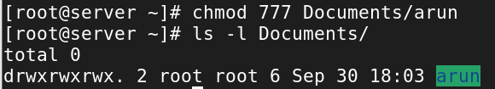

* What does the numeric representation 644 mean in terms of file permissions?

**First Digit (6)**:

* Represents the permissions for the **user (owner)** of the file.
* **6** is calculated as:
  + 4 (read) + 2 (write) = **6** (read and write permissions).
* So, the owner can read and modify the file but cannot execute it.

**Second Digit (4)**:

* Represents the permissions for the **group** associated with the file.
* **4** means:
  + 4 (read) = **4** (read permission only).
* The group can read the file but cannot modify or execute it.

**Third Digit (4)**:

* Represents the permissions for **others** (all other users).
* **4** means:
  + 4 (read) = **4** (read permission only).
* Others can read the file but cannot modify or execute it.
* How can you change the permissions of a directory in Linux?

Syntax:

* chmod <modes><directory_name>

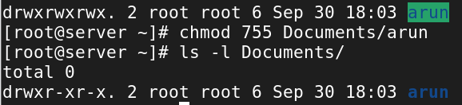

* What does the "x" permission mean for a directory?

**Access Control**:

* Allows a user to **traverse into the directory** and access its contents.

**Required for Listing**:

* A user needs both **read (r)** and **execute (x)** permissions to list the directory’s contents using commands like ls. Without execute permission, they cannot list files even if they have read permission.

**Accessing Files**:

* Users can access files within the directory if they know the filenames, even without read permission on the directory.
* How do you recursively change the permissions of all files and directories within a directory?
* To **recursively change the permissions** of all files and directories within a directory in Linux, you can use the chmod command with the -R (recursive) option.

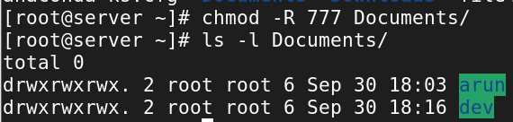

* What is the difference between the chmod command and the chown command?

**chmod Command**

* **Purpose**: Changes **file permissions** (read, write, execute).
* **Functionality**: Modifies access rights for user (owner), group, and others.
* **Impact**: Affects who can read, write, or execute a file but does not change ownership.

**chown Command**

* **Purpose**: Changes **file ownership** (user and group).
* **Functionality**: Modifies the owner and/or group associated with a file or directory.
* **Impact**: Affects who is considered the owner and which group a file belongs to, influencing access permissions.
* How can you check the permissions of a directory using the ls command?
* Check the permissions of a directory in Linux using the ls command with the -l option.

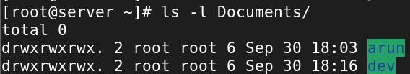

**7. Vi editor in Linux:**

* What is the purpose of the Vi editor in Linux?

**Text Editing**:

* Used to create and edit text files, such as configuration files and scripts.

**Terminal-Based**:

* Works in a command-line interface, suitable for server environments without a GUI.

**Modal Editing**:

* Operates in different modes:
  + **Normal Mode**: For navigation and commands.
  + **Insert Mode**: For adding and editing text.
  + **Command Mode**: For executing commands like saving or quitting.

**Powerful Features**:

* Includes advanced search and replace, and the ability to create macros for repetitive tasks.

**Multi-File Editing**:

* Allows users to edit multiple files in a single session.

**Customization**:

* Can be customized with configuration options for personal preferences.
* What is the command to open a file in Vi for editing?

Syntax:

* vi <file_name>

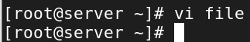

* How do you switch to insert mode in Vi to start adding or modifying text?
* Press i, I, a, A, o, or O in Vi to switch to insert mode and start adding or modifying text.

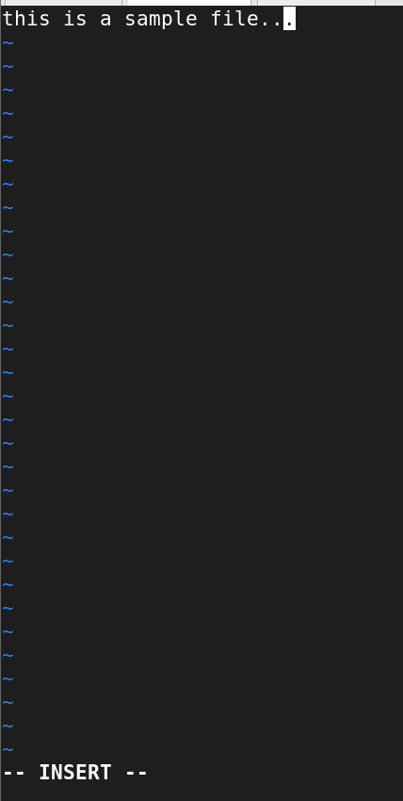

* How do you save changes and exit Vi?
* To save changes and exit Vi, press Esc, type :wq, and then press Enter.
* Use :w to save only and :q! to exit without saving.
* What is the command to exit Vi without saving changes?
* Use :q! and press Enter to exit Vi without saving changes.

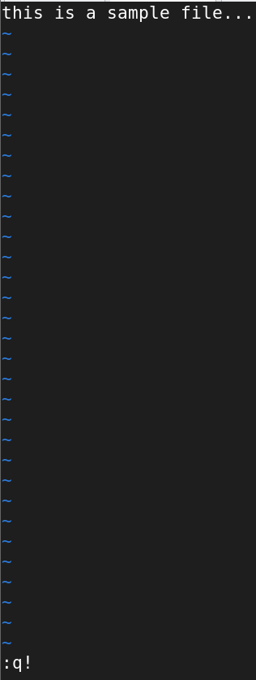

* How can you move the cursor to the beginning and end of a line in Vi?
* **Beginning of Line**: Press 0.
* **End of Line**: Press $.
* What is the command to search for a specific word or pattern in Vi?
* Use /word and press Enter to search for a specific word or pattern in Vi. Press n to navigate to the next occurrence.

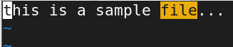

* How can you delete a character or a line in Vi?
* **Delete a Character**: Press x to delete the character under the cursor.
* **Delete a Line**: Press dd to delete the current line. Use 3dd to delete three lines.
* How do you copy and paste text in Vi?
* **Copy a Line**: Press yy. For multiple lines, use 3yy (to copy three lines).
* **Copy Selected Text**: Use visual mode (v), select the text, and then press y.
* **Paste**: Press p to paste after the cursor or P to paste before the cursor.
* What are some basic navigation commands in Vi to move between different sections of a file?
* Use **k, j, h, and l** to **move up, down, left, and right**.
* Use **0** to move to the **beginning of a line** and **$** to **move to the end**.
* Use **gg** and **G** to move to the **first and last lines of a file**.
* Use **w** and **b** to **move between words**, and **{ and }** to **navigate paragraphs**.
* Use **Ctrl + u** and **Ctrl + d** to **move up and down by half a page**.
* How do you search for a specific word or phrase in Vi?
* Use **/word_or_phrase** and press **Enter** to search for a **word or phrase** in Vi.
* Use **n** to **move to the next match** and **N** to **move to the previous match**.
* What is the difference between the :w and :wq commands in Vi?

**:w Command:**

* **Purpose**: Saves the changes made to the file but **does not exit** the editor.
* **Use Case**: Use :w when you want to save your progress but continue editing the file.

**:wq Command:**

* **Purpose**: Saves the changes and **exits** the Vi editor.
* **Use Case**: Use :wq when you want to save your changes and then quit the editor.
* How do you delete a single character in normal mode?
* Use **x** in normal mode to **delete a single character** at the cursor position.

**8. Special permissions in Linux:**

* What are the three special permissions in Linux?

**Setuid (Set User ID)**

* **Setuid (s)** 🡪 Execute file as owner.
* **Purpose**: Allows a file to be executed with the permissions of its owner, rather than the user who is executing it.

**Setgid (Set Group ID)**

* **Setgid (s)** 🡪 Inherit group ownership.
* **Purpose**: When applied to a directory, files created within inherit the group of the directory, rather than the group of the user creating the files.

**Sticky Bit**

* **Sticky Bit (t) 🡪** Restrict file deletion in directories.
* **Purpose**: When set on a directory, it restricts file deletion. Only the owner of the file, the owner of the directory, or the root user can delete or rename the files within.
* What is the purpose of the setuid permission?
* **Symbol**: s in the **user** (owner) permissions.
* **Purpose**: Allows a file to be executed with the permissions of its owner, rather than the user who is executing it.
* **Common Use**: Typically used on executable files to grant elevated privileges (e.g., /usr/bin/passwd).
* How is the setuid permission represented in the output of the ls -l command?
* The **setuid** permission appears as an **s** in place of the **execute (x)** permission in the **user** (owner) section.
* It is represented as **rws** if the user has **read, write, and setuid** permissions.
* If the **execute permission** is not set, it appears as **r-S** (uppercase S).

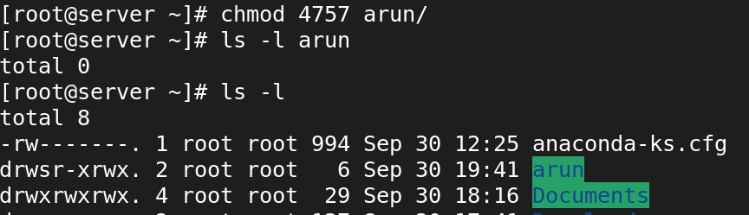

* What is the effect of the setuid permission on an executable file?
* If we give setuid permission for executable files, normal users can access the files.
* What is the purpose of the setgid permission?
* **Symbol**: s in the **group** permissions.
* **Purpose**: When applied to a directory, files created within inherit the group of the directory, rather than the group of the user creating the files.
* **Common Use**: Ensures group ownership consistency within directories.
* How is the setgid permission represented in the output of the ls -l command?
* The **setgid** permission appears as an **s** in place of the **execute (x)** permission in the **group** section.
* It is represented as **rws** if the group has **read, write, and setgid** permissions.
* If the **execute permission** is not set, it appears as **r-S** (uppercase S).

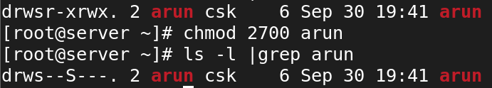

* What is the effect of the setgid permission on a directory?
* If we give setgid for a directory, all files and directory created in that directory is owned by the same common group.





* What is the purpose of the sticky bit permission?
* **Symbol**: t in the **others** permissions.
* **Purpose**: When set on a directory, it restricts file deletion. Only the owner of the file, the owner of the directory, or the root user can delete or rename the files within.
* **Common Use**: Typically used on shared directories like /tmp to prevent users from deleting each other's files.
* How is the sticky bit permission represented in the output of the ls -l command?
* The **sticky bit** appears as a **t** in place of the **execute (x)** permission in the **others** section.
* If the **execute permission** is set for others, it appears as **t**.
* If the **execute permission** is not set for others, it appears as **T** (uppercase T).

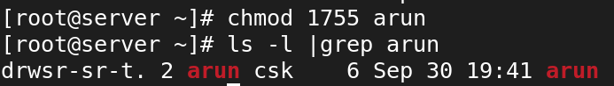

* What is the significance of the sticky bit on a directory?

**Purpose of the Sticky Bit on a Directory**

* It **restricts deletion or renaming** of files within the directory.
* Only the **owner** of the file, the **owner of the directory**, or the **root user** can delete or rename files inside the directory, **even if other users have write permissions**.

**Use Case**

* This is particularly useful in **shared directories**, such as /tmp, where many users have write access. The sticky bit prevents users from accidentally or maliciously deleting or modifying each other’s files.

**9. User and Group administration in Linux:**

* What is the command to create a new user in Linux?
* **useradd** command is used to create a new user in Linux.

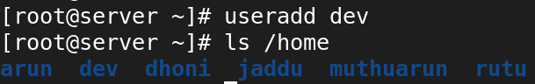

* How can you specify a user's home directory during user creation?
* Use **useradd -d /path/to/home username** to specify a home directory during user creation.

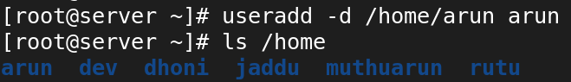

* How do you assign a password to a user account in Linux?
* Use **passwd username** to assign or change a password for a user account.

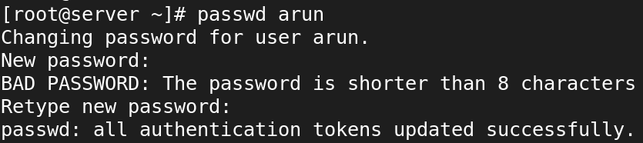

* What command is used to delete a user from the system?
* **userdel** command is used to delete a user from the system.

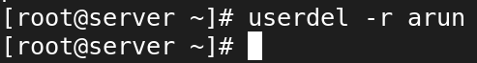

* How can you add an existing user to a specific group?
* Use **usermod -aG groupname** username to add an existing user to a specific group.

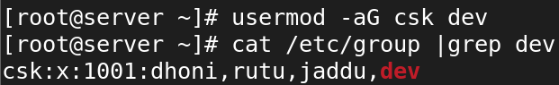

* What command is used to create a new group in Linux?
* groupadd command is used to create a new group in Linux.

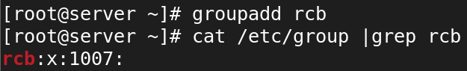

* How do you add a user to a newly created group?
* Use **usermod -aG groupname** username to add a user to a newly created group.



* What is the purpose of the chgrp command?
* **Change Group Ownership**: It allows the user to change the group associated with a file or directory to a specified group.
* **Manage Access Control**: By changing the group ownership, it helps in managing permissions and access control for files and directories, allowing members of a group to access shared resources.

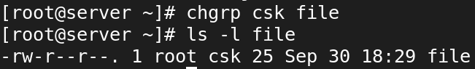

* How can you list all the users on a Linux system?
* **/etc/passwd** 🡪 Displays all user accounts.

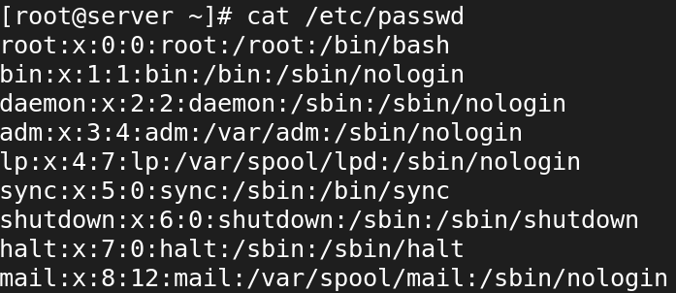

* What command can you use to modify a user's account settings, such as their shell or home directory?
* Use the **usermod** command to modify user account settings such as shell or home directory.

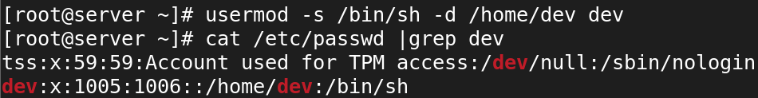

* How do you list all the users on a Linux system?
* **cat /etc/passwd**: Shows all user account information.



* What command is used to add a new user in Linux?
* Use useradd username to create a new user in Linux.



* How can you assign a user to a specific group during user creation?

Syntax:

* useradd -G <group_name><user_name>

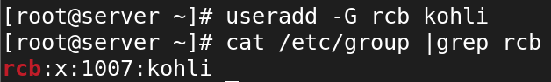

* What is the purpose of the usermod command?
* **Change User Information**: Modify various attributes of an existing user account, such as the username, user ID (UID), group ID (GID), home directory, and login shell.
* **Manage Group Membership**: Add or remove the user from specific groups, which can affect their permissions and access to resources.
* **Update User Settings**: Change other user-related settings, such as password expiration and account status.
* How do you change a user's password in Linux?
* Use passwd username to change a specific user's password.

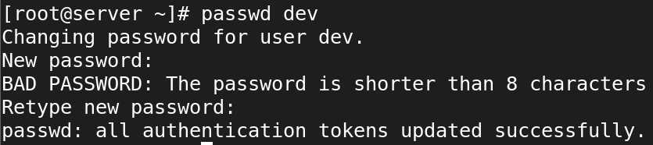

* How do you lock or unlock a user account using the passwd command?
* **Lock an account**: Use passwd -l username

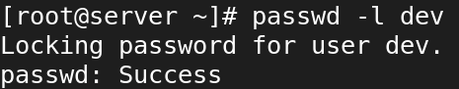

* **Unlock an account**: Use passwd -u username

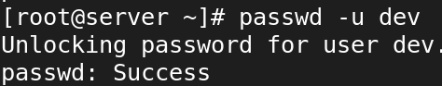

* What is the purpose of the groupadd command?
* **Create New Groups**: It allows administrators to define new groups for managing user permissions and access control efficiently.
* **Facilitate Resource Sharing**: By creating groups, users can share access to files and resources more easily, as permissions can be set for the group rather than for individual users.
* **Organize User Management**: Groups help organize users based on roles or projects, making it easier to manage user permissions in a structured manner.
* How do you add an existing user to an existing group?
* To add an existing user to an existing group in Linux, you can use the **usermod** command with the **-aG** option.



* How can you remove a user from a group?
* Use gpasswd -d username groupname to remove a user from a group.

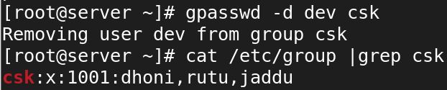

* What command is used to delete a user account in Linux?
* **userdel** command is used to delete a user from the system.



* How do you display the details of a specific user, including their group memberships and other information?
* Use **id username** to display user details, including group memberships.



* How can you create a new group and set its GID (Group ID) using the groupadd command?
* Use groupmod -g (GID) <group_name> is used to create a new group and its GID.

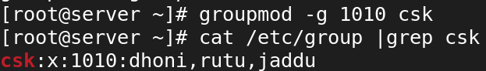

* What is the difference between the useradd and adduser commands?

**USERADD:**

* useradd is a low-level command that directly modifies system files to create a user.
* useradd does not prompt for any information and requires all necessary options to be provided directly in the command line.
* useradd does not apply any defaults unless explicitly specified; it often requires additional options to create a home directory and set the default shell.
* useradd is universally available on all Linux distributions as part of the standard utility.

**ADDUSER:**

* adduser is a high-level command (often a script) that provides a user-friendly interface for creating users.
* adduser prompts the user for various details, such as the password and user information, making it more interactive.
* adduser automatically creates a home directory and applies sensible defaults without needing multiple options.
* adduser is typically found in Debian-based distributions (like Ubuntu) and may not be available on other distributions.
* How can you list all the groups on a Linux system?
* Use cat /etc/group to list all groups on the system.

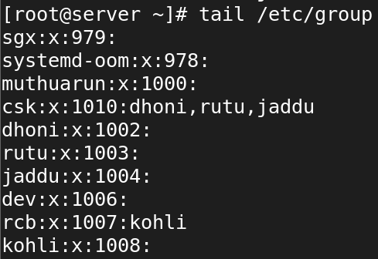

* What is the purpose of the /etc/passwd file in Linux?
* /etc/passwd 🡪 Contains essential details about user accounts.
* username:password_placeholder:UID:GID:User_Info:Home_Directory:Login_Shell
* Integral to the authentication process, linking usernames to their account details.
* Used by system utilities and commands to retrieve user information for management and access control.
* What information does each line in the /etc/passwd file represent?
* **Username**: The name used to identify the user.
* **Password Placeholder**: Typically, an "x", indicating that the password is stored securely in the /etc/shadow file.
* **User ID (UID)**: A unique numeric identifier assigned to the user.
* **Group ID (GID)**: The primary group ID associated with the user.
* **User Information**: Optional field that may contain additional information about the user (e.g., full name).
* **Home Directory**: The path to the user's home directory.
* **Login Shell**: The default shell that the user will use upon logging in.
* How can you view the contents of the /etc/passwd file?
* Use cat /etc/passwd for a full display.



* What is the purpose of the /etc/shadow file?
* /etc/shadow file is vital for securely storing user passwords and related account information, enhancing overall system security by restricting access and separating sensitive data from general user account details.
* How is the /etc/shadow file different from the /etc/passwd file?

**/etc/passwd:**

* Stores basic user account information.
* Readable by all users (with limited access)
* Contains a placeholder for the password (usually "x")
* Username, UID, GID, home directory, shell, etc.
* Less secure due to broader access.
* Typically modified with user management commands like useradd or usermod.

**/etc/shadow:**

* Stores secure password hashes and account settings.
* Accessible only by the root user and privileged processes.
* Contains the hashed passwords directly.
* Password hash, last password change date, expiration details, etc.
* More secure due to restricted access and hashed passwords.
* How can you view the contents of the /etc/shadow file?
* Use cat /etc/shadow for a full display.

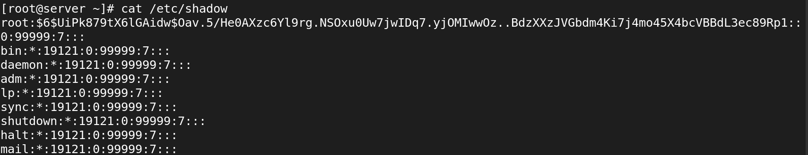

* What is the purpose of the /etc/gshadow file?

**Secure Group Passwords**:

* The primary purpose of the /etc/gshadow file is to store group passwords securely. This allows groups to have a password that members must provide to access certain resources or files associated with that group.

**Group Membership Information**:

* The file contains information about group members, specifying which users are members of each group. This can include normal members and administrators.

**Structure**:

* Each line in the file represents a group and has the following format:
  + **Group Name**: The name of the group.
  + **Encrypted Group Password**: The hashed password for the group (if any).
  + **Group Administrators**: A comma-separated list of users who have administrative rights over the group.
  + **Group Members**: A comma-separated list of regular members.

**Access Control**:

* Similar to the /etc/shadow file, the /etc/gshadow file is accessible only by the root user and privileged processes, providing an additional layer of security.
* How is the /etc/gshadow file different from the /etc/group file?

**/etc/group:**

* Stores basic group information, including group names and memberships
* Readable by all users
* Contains group name, GID, and member usernames
* Does not store group passwords (or placeholders)
* Each line contains: group_name:password:GID:members
* Typically modified with commands like groupadd, groupdel, and groupmod

**/etc/gshadow:**

* Stores secure group passwords and detailed membership information
* Accessible only by the root user and privileged processes
* Contains encrypted group password, group administrators, and members
* Stores the hashed password for the group, if any
* group_name: encrypted_password: administrators:members
* Typically modified with gpasswd or vigr for secure editing
* How can you view the contents of the /etc/gshadow file?
* Use cat /etc/gshadow to view the contents of the group password details.

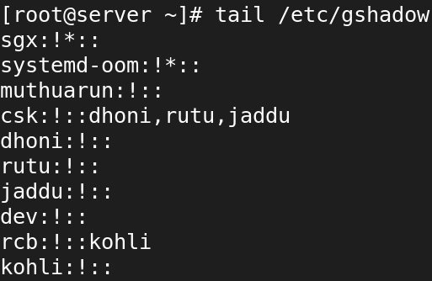

* What is the purpose of the /etc/group file in Linux?

**Group Information Storage**:

* The primary purpose of the /etc/group file is to store information about user groups on the system, including group names, group IDs (GIDs), and group memberships.

**User Membership**:

* It defines which users belong to which groups, allowing for easier management of permissions and access control across the system.

**Structure**:

* + group_name:password:GID:member1,member2,...
  + **group_name**: The name of the group.
  + **password**: A placeholder for the group password (often left empty).
  + **GID**: The unique Group ID number assigned to the group.
  + **members**: A comma-separated list of usernames that are members of the group.

**Access Control**:

* Groups are used to define access permissions for files and resources, allowing multiple users to share access to the same files without changing ownership.

**User Management**:

* The file is used by various system commands and utilities to manage and control user groups.
* How can you view the contents of the /etc/group file?
* Use cat /etc/group is used to view the contents of the group details.

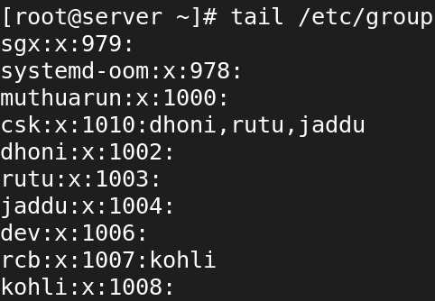

* What information does each line in the /etc/group file represent?
* **group_name**: Name of the group.
* **password**: Group password placeholder (usually empty).
* **GID**: Unique Group ID number.
* **members**: List of group member usernames.
* How can you add a new user to the /etc/passwd file and assign them to a group?
* -m: Creates a home directory for the new user.
* -g group_name: Specifies the primary group to which the user will belong.
* username: The name of the new user you want to create.

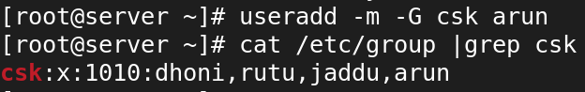

* How do you lock or disable a user account in the /etc/shadow file?

**Lock the user account in /etc/shadow: (passwd -l <username>)**

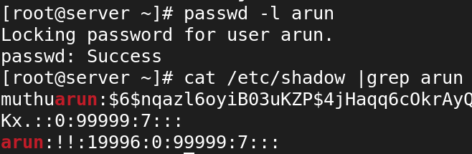

**Unlock the user account in /etc/shadow: (passwd -u <username>)**

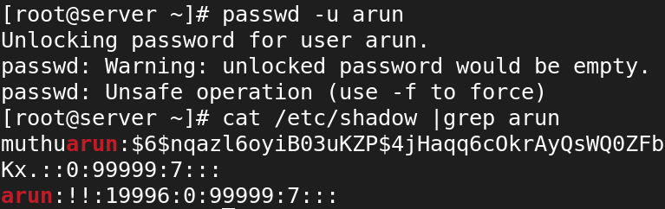

* What command is used to modify user group memberships in the /etc/group file?

Syntax:

* usermod -aG <groupname> <username>

**10. Processes in Linux:**

* What is a process in Linux?
* A process in Linux is a running instance of a program that includes its execution context, unique identifier, memory space, and system resources.
* It is managed by the Linux kernel, which provides the necessary tools for creating, scheduling, and terminating processes.
* How can you view the currently running processes in Linux?
* We can use ‘top’ and ‘ps aux’ to view the currently running processes in Linux.

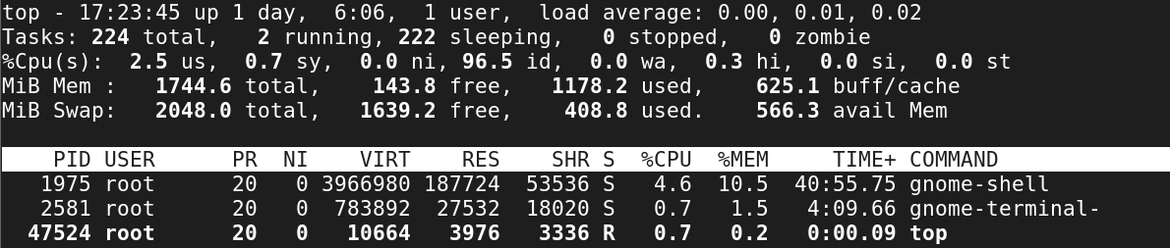

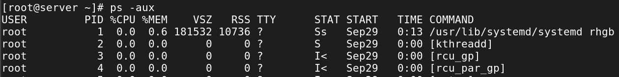



* What command is used to start a new process in Linux?
* You can start new process by simply typing the name of the command
* How can you identify the process ID (PID) of a running process?
* Top
* Ps aux
* Pidof (process name)



* What is the purpose of the ps command in Linux?

**View Active Processes**:

* Lists the processes currently running on the system for the user who executes the command.

**Check Process Status**:

* Provides detailed information such as process ID (PID), CPU and memory usage, and the command that started the process.

**Monitor System Resource Usage**:

* Allows users to monitor resource consumption by different processes.

**Identify Specific Processes**:

* Helps find specific processes based on criteria like process name, PID, or user.
* How can you terminate a process in Linux?
* Kill -9 (pid)
* Kill -15(pid)
* Killall (process name)
* Pkill (process name)



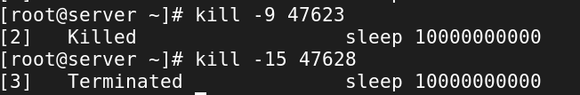

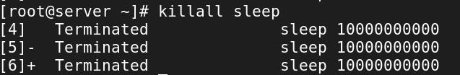

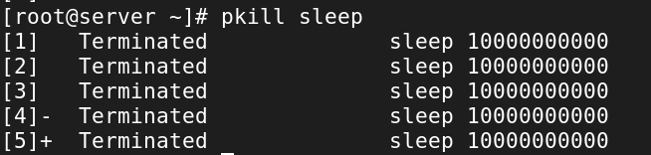

* What is the difference between a foreground process and a background process?

**Foreground Process**:

* Runs interactively, holding the terminal until completion.

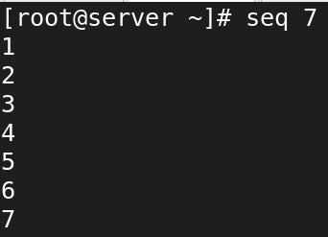

**Background Process**:

* Runs independently, freeing the terminal for other commands.

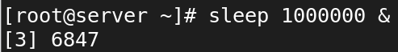

* How do you start a process in the background in Linux?
* To start a process in the background in Linux, you can use the & (ampersand) symbol at the end of the command.



* How can you check the status of a specific process in Linux?
* The ps -p command shows information about running processes.

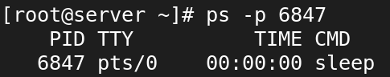

* What is a parent process and a child process in Linux?

**Parent Process:**

**Definition:**

* A parent process is a process that creates (or spawns) one or more child processes. It controls and manages these child processes.

**Identification:**

* Each parent process has a unique Process ID (PID) and a Parent Process ID (PPID) which refers to its parent.

**Child Process:**

**Definition**:

* A child process is a process created by a parent process. It inherits certain attributes from the parent, such as environment variables and file descriptors.

**Behavior**:

* When a child process is created, it can execute independently but is managed by the parent.
* How can you change the priority of a process in Linux?
* Nice –n (nice value) (process pid)



* renice (nice value) (process pid)



* What is the purpose of the top command in Linux?

**Monitor System Performance**:

* Displays the overall CPU and memory usage of the system.

**View Active Processes**:

* Lists the processes currently running, sorted by resource usage.

**Identify Resource-Intensive Processes**:

* Helps to identify which processes are consuming the most CPU or memory resources.

**Real-Time Updates**:

* Continuously updates the displayed information, allowing users to track changes in real-time.

**Manage Processes**:

* Users can kill or renice (change the priority) of processes directly from the top interface.
* How can you monitor the resource usage of a process in Linux?
* **top** : For real-time monitoring of CPU and memory.
* **ps**: For snapshot of resource usage.
* **pidstat**: For process-specific resource usage.
* What is the significance of the process states, such as "Running," "Sleeping," and "Zombie"?
* Running 🡪 currently running process.
* Sleeping 🡪 the process is sleeping but we can wake up it.
* Zombie 🡪 process terminated but the status was not collected.
* How can you send signals to a running process in Linux?
* Kill -3 it will send a messege to the process to quit the process
* Kill -9 it will terminate the process the forcefully
* Kill -15 it will terminate the process
* Kill -18 to stop the process
* Kill-19 to continue the stopped process
* How do I run the top command?



* What information does the top command display?



* How do I interpret the CPU usage information shown by top?
* The top command provides detailed CPU usage statistics that can help diagnose performance issues.
* Understanding the meaning of each CPU state is crucial for identifying bottlenecks or resource contention.
* Use the information to monitor system performance and make informed decisions about process management or resource allocation.
* How can I sort processes based on different criteria (e.g., CPU usage, memory usage) in top?

**Sort by CPU Usage**:

* Press **Shift + P** (uppercase 'P') to sort processes by CPU usage in descending order.

**Sort by Memory Usage**:

* Press **Shift + M** (uppercase 'M') to sort processes by memory usage in descending order.

**Sort by Process ID**:

* Press **Shift + N** (uppercase 'N') to sort processes by their Process ID (PID).

**Sort by Time**:

* Press **Shift + T** (uppercase 'T') to sort processes by the cumulative CPU time.
* Is it possible to change the update frequency of top to see real-time changes more or less frequently?
* Yes, you can change the update frequency of the top command in Linux to adjust how often the display refreshes to show real-time changes.
* while running top command
* press ‘d’ for delay
* then give any num like 1 means ,you can view updated intervals in seconds.
* How can I view only the processes of a specific user with top?

Syntax:

* ps –u <username>

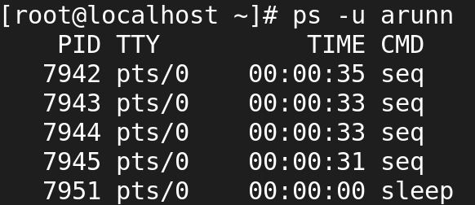

* What are the basic navigation keys in top for sorting and filtering processes?

**Sort by CPU Usage**:

* **Shift + P**: Sort processes by CPU usage in descending order.

**Sort by Memory Usage**:

* **Shift + M**: Sort processes by memory usage in descending order.

**Filter by User**:

* **u**: Filter processes to display only those belonging to a specific user. After pressing u, enter the username and press **Enter**.

**Search for a Process**:

* **/**: Start a search for a specific process by name. Type the name or part of the command and press **Enter** to filter the displayed processes.

**Exit top**:

* **q**: Exit the top interface and return to the command prompt.
* Can top show the full command line used for each process?

**Start the top Command**:

* Open your terminal and type:

**Toggle Full Command Line Display**:

* While in the top interface, press **c**. This toggles between showing the command name (the default) and the full command line used to start each process.

**View the Full Command Line**:

* After pressing **c**, you will see the full command line for each process displayed in the COMMAND column.
* How do I kill a process directly from top?

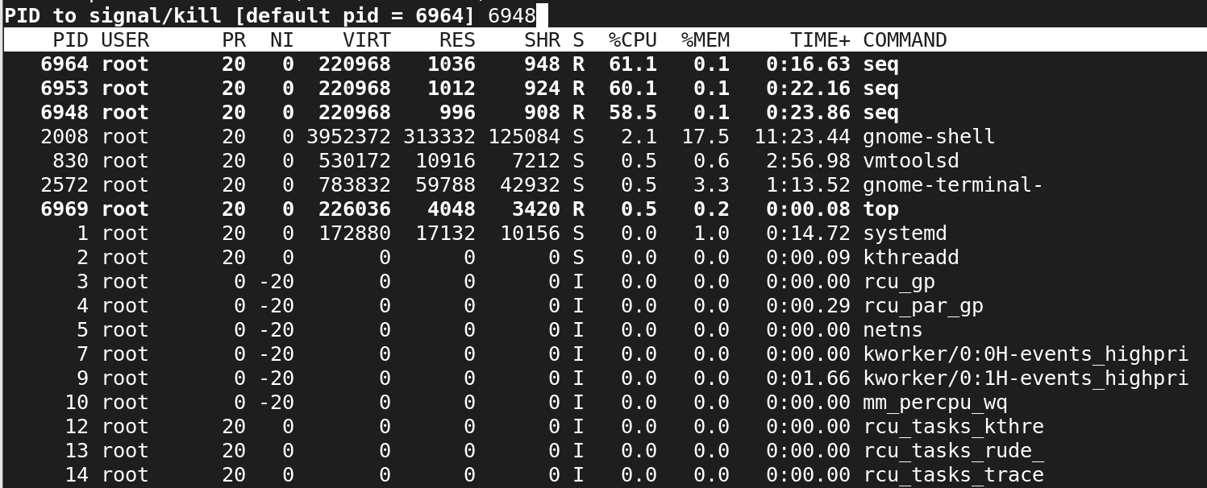

* Can top show the overall memory and CPU usage summary for the system?
* The top command gives you a real-time overview of CPU and memory usage, allowing you to monitor system performance and resource utilization effectively.
* This summary is updated in real-time, providing valuable information for system administrators and users.
* Is there a way to display the top output in a non-interactive mode (e.g., for scripting purposes)?

Syntax:

* Top -b -n 1

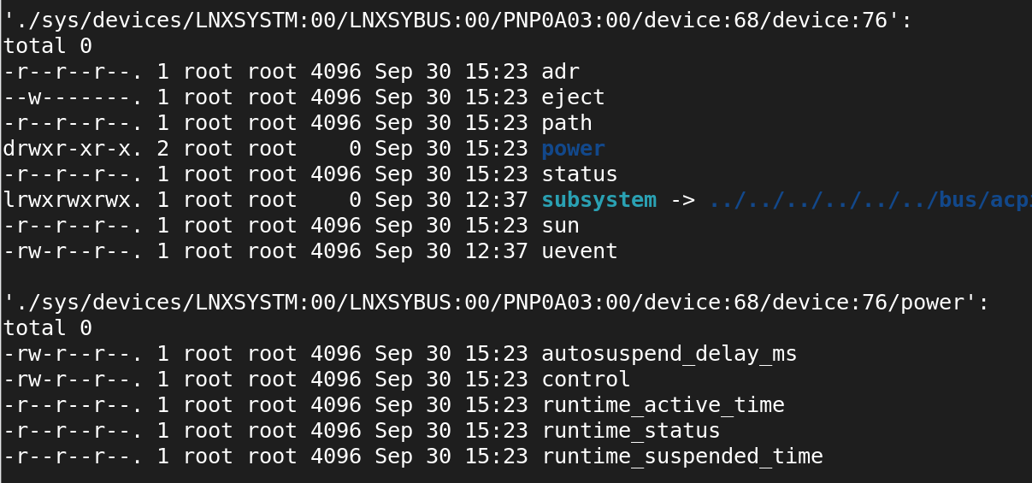

* What do the different colors and flags represent in the top output?
* Green for running processes.
* Red for processes using a lot of CPU.
* Blue for processes in a sleep state. The specific meanings can depend on the terminal and top version.
* How can I adjust the priority of a process using top?
* While in top, you can change the priority by selecting a process and pressing r, then entering the new priority value.
* Are there alternative commands or utilities similar to top for monitoring system performance?
* htop (more user-friendly and interactive).
* glances (provides a comprehensive overview).
* atop (tracks system resources over time).
* How can I save the top output to a file for later analysis?
* top -b -n 1 > file or dir name 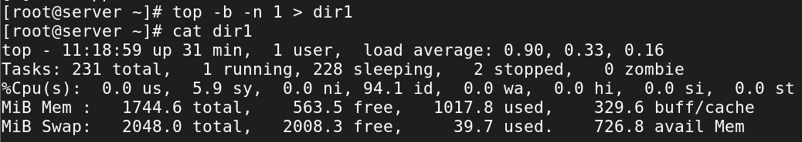
* How can you terminate a process in Linux?
* Kill command is used to terminate the process.
* # kill -9 pid
* # pkill pid
* # killall <process name>
* What is the difference between a foreground process and a background process?
* Foreground Process: Runs in the foreground and occupies the terminal, allowing user interaction.
* Background Process: Runs in the background, freeing the terminal for other commands. You can start it with an &.
* How do you start a process in the background in Linux?
* To start ia new process in the background ,append & at the end of command

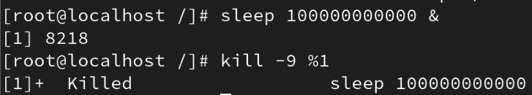

* How can you check the status of a specific process in Linux?
* You can filter by user in top by pressing u and entering the username

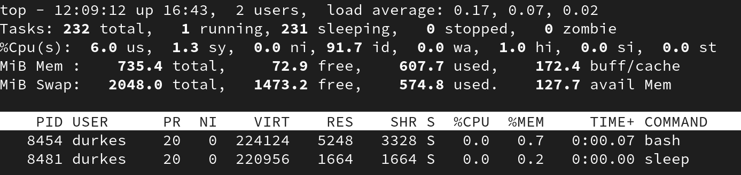

* What is a parent process and a child process in Linux?

**Parent Process**

* A **parent process** is a process that initiates or creates one or more child processes.
* When a process starts another process (e.g., using the fork() system call in C or creating a new shell process), it becomes the parent of that process.
* Each process in Linux has a unique **Process ID (PID)** and a **Parent Process ID (PPID)**, which links it to its parent.

**Child Process**

* A **child process** is a process that is created by another process (the parent process).
* A child process inherits several attributes from its parent, such as environment variables, open file descriptors, and some settings.
* After creation, a child process runs independently and may execute the same or a different program.
* The child process has its own unique PID, but it is associated with the parent’s PPID.
* How can you change the priority of a process in Linux?
* Renice command is used to change the priority of a process in Linux.

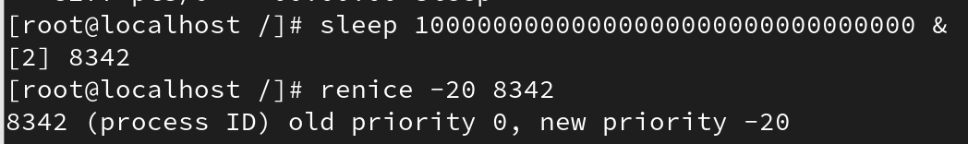

* What is the purpose of the top command in Linux?
* The top command in Linux is a powerful utility used to display real-time information about the system’s processes and resource usage.
* It provides a dynamic, interactive view of system performance, making it valuable for monitoring CPU and memory usage, identifying resource-intensive processes, and troubleshooting system performance issues.

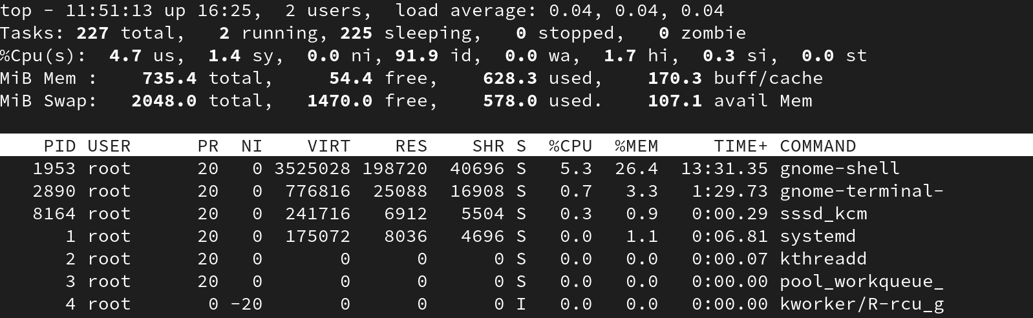

* How can you monitor the resource usage of a process in Linux?

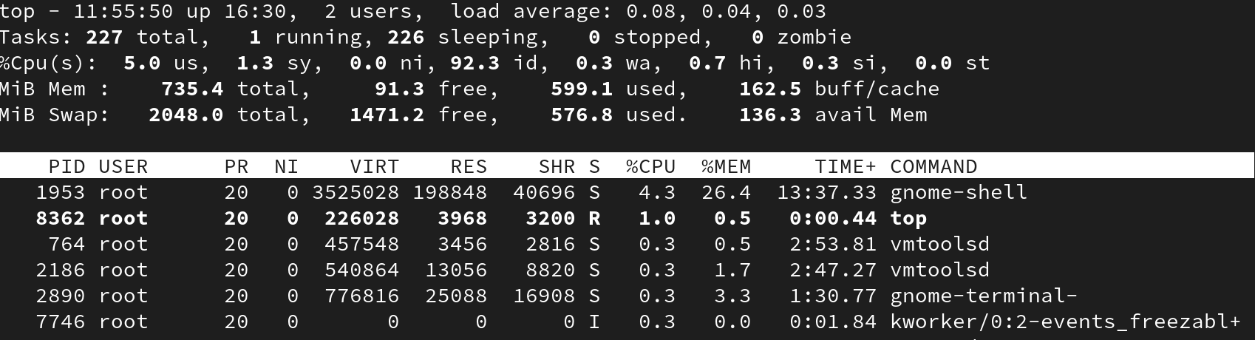

* What is the significance of the process states, such as "Running," "Sleeping," and "Zombie"?

**1. Running (R):**

* **Definition**: A process in the **Running** state is either actively using the CPU or ready to use the CPU as soon as it gets scheduled.
* **Significance**: This is the state when the process is actively executing instructions on the CPU.

**2. Sleeping (S or D):**

* **Definition**: A **Sleeping** process is one that is not actively using the CPU because it is waiting for some event to complete (e.g., waiting for I/O, a signal, or a resource).
* **Two types of sleeping states**:
  + **Interruptible Sleep (S)**: The process is waiting for an event, such as input/output operations, and can be interrupted by signals (e.g., keyboard input or a timer).
  + **Uninterruptible Sleep (D)**: The process is waiting for a hardware-related event that cannot be interrupted by signals, like waiting for a disk read/write to complete.

**3. Zombie (Z):**

* **Definition**: A **Zombie** process is a terminated process whose resources have been released but whose **process descriptor** remains in the system because the parent process has not yet read the exit status of the child (via the wait() system call).
* **Significance**:
  + A zombie process is not consuming system resources like CPU or memory but still occupies a **process ID (PID)** slot.
* How can you send signals to a running process in Linux?

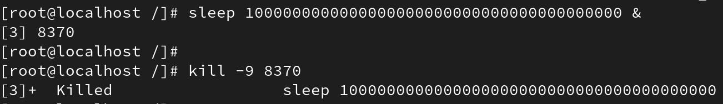

**11. Services in Linux:**

* What is a service in the context of Linux?
* A service in Linux is a background process that provides specific functions or capabilities to users and applications.
* Services are managed by the operating system, often run as daemon processes, and can be controlled using various management tools.
* They play a crucial role in the overall functionality and performance of a Linux system.
* How can you check the status of a service in Linux?
* Use systemctl status service-name to check the status of a service in Linux.

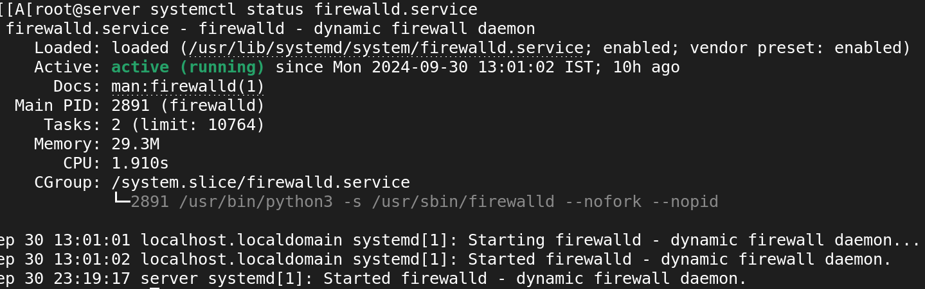

* What command is used to start a service in Linux?

Syntax:

* systemctl start <service_name>

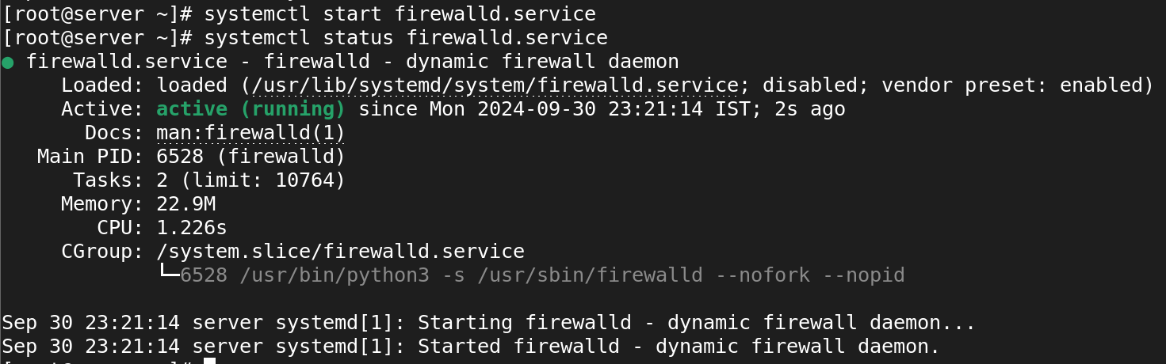

* How can you stop a running service in Linux?

Syntax:

* Systemctl stop <service_name>

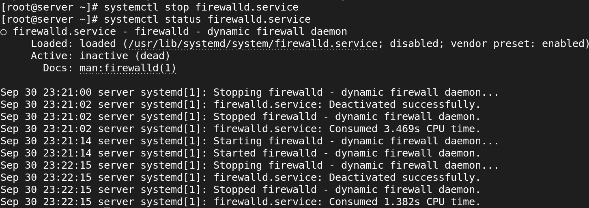

* What is the purpose of the systemctl command in Linux?
* The systemctl command serves as a comprehensive interface for managing systemd services and the overall system state in Linux.
* It provides an efficient way to control services, view their status, enable or disable them, and manage logs and system operations, making it a critical tool for system administrators.
* How can you enable a service to start automatically at system boot in Linux?

Syntax:

* systemctl enable <service_name>

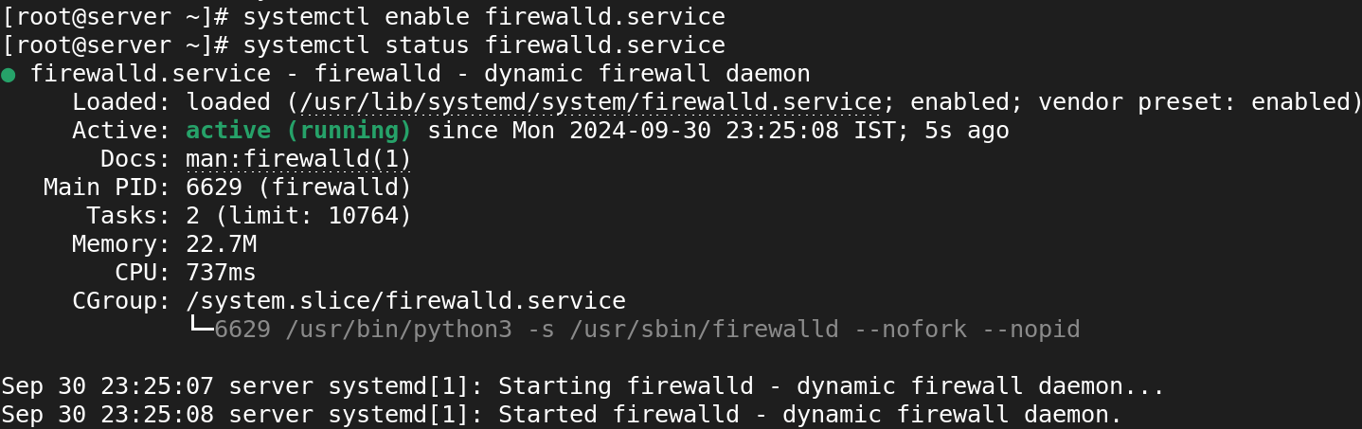

* What is the difference between a system service and a user service in Linux?
* **System Services**:
  + These are services that run in the background and are managed by the system’s init system (like systemd or SysVinit). They typically start at boot time and run with system-level privileges.
* **User Services**:
  + These are services that are started and managed by individual user sessions. They run in the context of a specific user and do not require elevated privileges. User services can be started manually by the user or automatically upon user login.
* How can you restart a service in Linux?

Syntax:

* systemctl restart <service_name>



* What command is used to view the list of available services in Linux?

Syntax:

* systemctl list-units –type=service

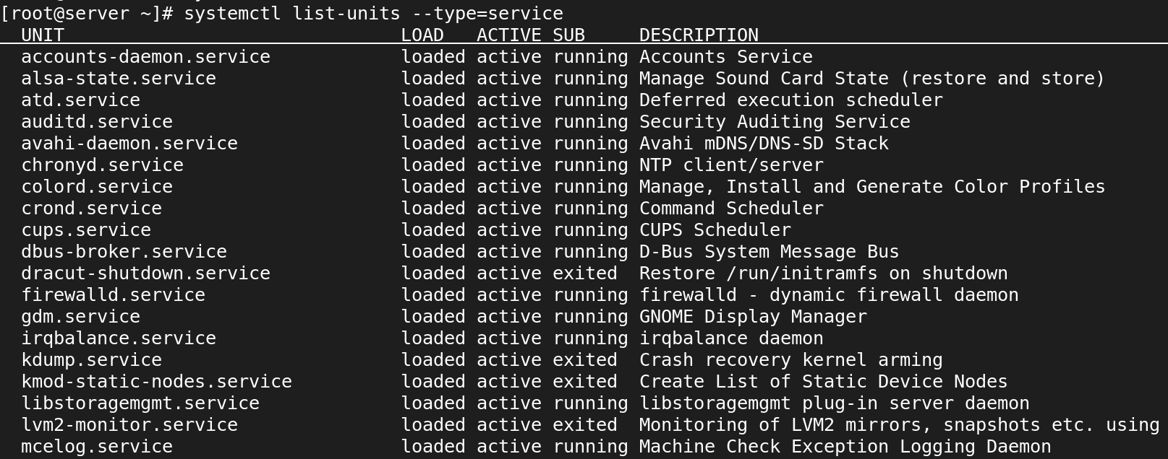

* How can you configure the behavior and settings of a service in Linux?
* vi /etc/<service>/<service config file>
* systemctl restart <service name>
* What is the purpose of the /etc/init.d directory in Linux?
* **Service Management**: Contains scripts to start, stop, and manage system services (daemons).
* **SysVinit System**: Part of the SysVinit system, used in older distributions to control services at different runlevels.
* **Runlevel Control**: Scripts can be executed with commands like service to manage services across various system states.
* **Naming Convention**: Each script is named after the service it controls (e.g., apache2, mysql).
* **Backward Compatibility**: Exists for compatibility with older scripts, even in modern systems using systemd.
* How can you create a custom service in Linux?
* How can you check the logs and debug a service in Linux?
* journalctl -u <service name> = it shows the logs of a service
* <service name> -d =it shows the debug of a service
* What is the significance of service dependencies in Linux?
* **Order of Startup**: Ensures services start in the correct sequence, preventing errors from unavailable resources.
* **Automatic Handling**: Systemd manages dependencies using directives (Requires, Wants, Before, After).
* **Fail-Safe Operation**: Prevents dependent services from starting if a required service fails, maintaining stability.
* **Improved Boot Performance**: Allows parallel service startup when there are no dependencies, speeding up boot time.
* **Resource Management**: Ensures dependent services wait for necessary resources (like network) to be available.
* **Simplified Configuration**: Clear dependencies help administrators understand service relationships, aiding in troubleshooting.
* **Lifecycle Management**: Manages starting and stopping of services while respecting dependencies, ensuring system integrity.

**12. Archiving and transferring files in Linux:**

* What command is used to create a tar archive of files and directories in Linux?

Syntax:

* tar -cvf etc-backup-19-09-2024.tar /etc

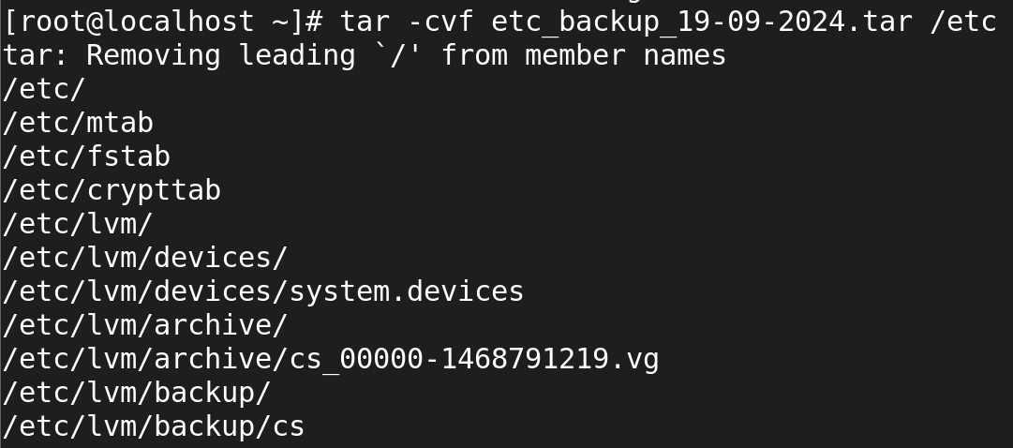

* How can you extract files from a tar archive in Linux?

Syntax:

* tar -xvf etc-backup.tar

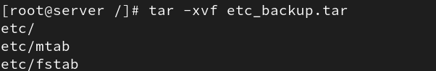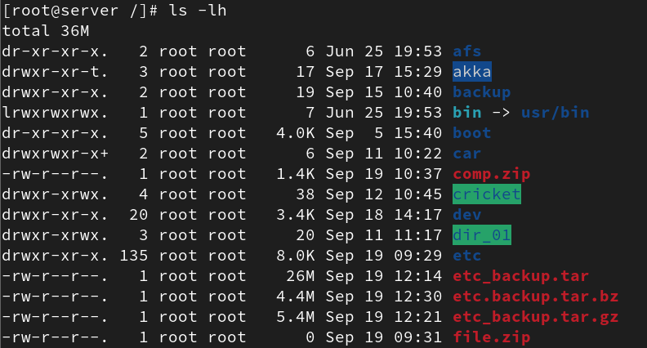

* What is the purpose of compression when creating an archive?
* **Space Savings**: Reduces file size, saving disk space.
* **Faster Transfers**: Smaller sizes lead to quicker uploads and downloads.
* **Efficiency**: Allows more data to be stored in less physical space.
* **Organization**: Consolidates multiple files into a single archive for easier management.
* **Data Integrity**: Some methods include checksums for error checking.
* **Backup Optimization**: Makes backup processes faster and less resource-intensive.
* Which command is used to compress files into a gzip archive in Linux?

Syntax:

* gzip filename



* How can you extract files from a gzip archive in Linux?

Syntax:

* gzip -d filename.gz

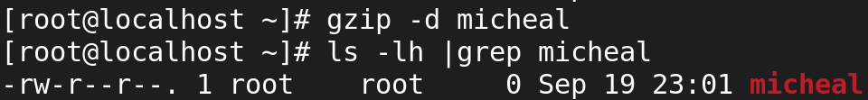

* How can you extract files from a bzip archive in Linux?

Syntax:

* tar -xvjf etc-backup.tar.bz2



* What is the difference between a tar archive and a compressed archive?

**Tar Archive:**

1. **Definition**:
   * A tar archive is a collection of files and directories bundled together into a single file using the tar (tape archive) command.
2. **Purpose**:
   * It consolidates multiple files and directories for easier storage or transfer without compressing them.
3. **File Extension**:
   * Typically has a .tar extension.
4. **Compression**:
   * By itself, a tar archive does not compress files. It simply groups them.

**Compressed Archive:**

1. **Definition**:
   * A compressed archive is a file that has been reduced in size using compression algorithms (like gzip, bzip2, or zip).
2. **Purpose**:
   * It reduces the file size to save storage space and make file transfers faster.
3. **File Extensions**:
   * Common extensions include .gz (for gzip), .bz2 (for bzip2), and .zip.

* How can you create a zip archive of files and directories in Linux?

Syntax:

zip conzip.zip file{1..5} arun

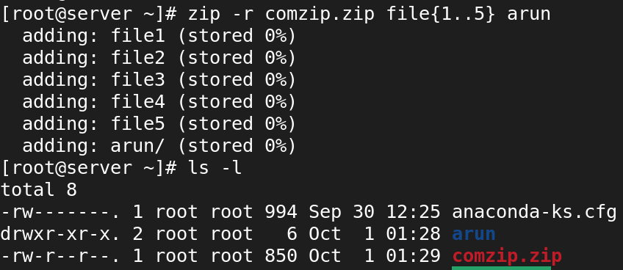

* What command is used to extract files from a zip archive in Linux?

Syntax:

* unzip comzip.zip

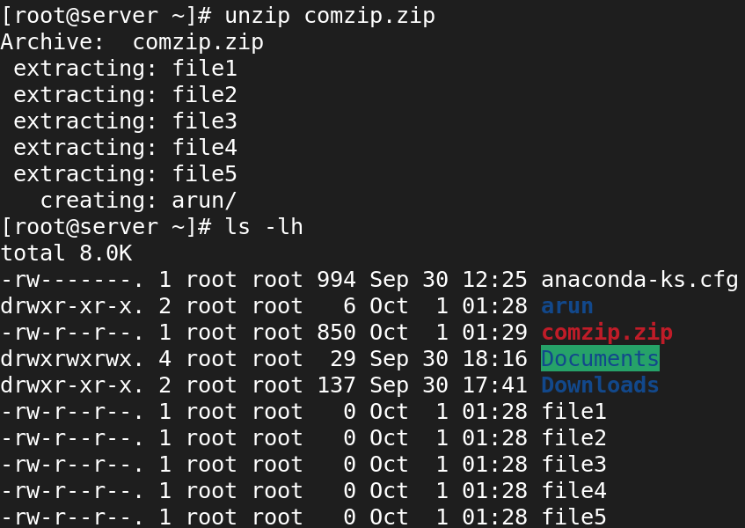

* How can you transfer files between Linux systems using the scp command?

Syntax:

* scp root@192.168.45.132:/root/file1 Music/

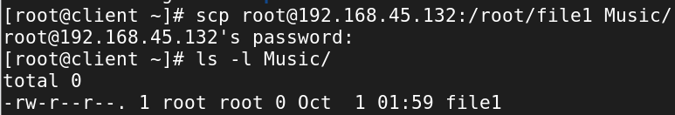

* What is the syntax for transferring a file using scp?

**Syntax:**

* scp [options] source_file user@destination_host:destination_path

**Components:**

* **scp**: The command for secure file transfer.
* **[options]**: Optional flags to modify the behavior of the command (e.g., -r for recursive copying).
* **source_file**: The path of the file you want to copy from the local machine.
* **user**: The username on the remote machine.
* **destination_host**: The IP address or hostname of the remote machine.
* **destination_path**: The path on the remote machine where you want to copy the file.
* How can you transfer an entire directory using scp?

Syntax:

* scp -r root@192.168.45.132:/root/dict1 Music/

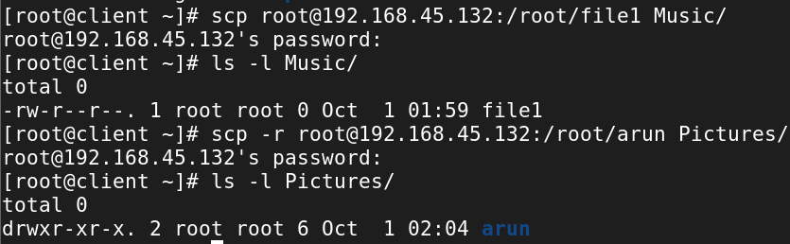

**13. Analysing and storing logs in Linux:**

* What is the purpose of log files in Linux?
* **System Monitoring**: Track system performance and activities.
* **Troubleshooting**: Provide error details for diagnosing problems.
* **Security Auditing**: Record access and modifications for security reviews.
* **Event Tracking**: Maintain a history of significant system events.
* **Compliance**: Ensure adherence to regulations and policies.
* How can you view the contents of a log file in Linux?
* You can use **cat, less, more, tail, or head commands** to view the contents of log files in Linux, depending on whether you want to see the entire file, scroll through it, or monitor changes in real-time.
* What command is used to search for specific keywords or patterns within a log file?
* To search for specific keywords or patterns within a log file in Linux, you can use the grep command.
* cat /var/log/messages|grep <specific keywords>

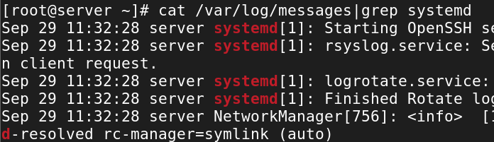

* How can you filter log entries based on specific criteria using the grep command?

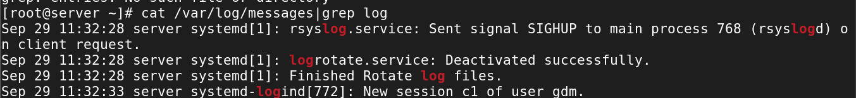

* What is the purpose of log rotation in Linux?
* **Prevent Disk Space Exhaustion**: Archives or deletes older logs to avoid excessive disk usage.
* **Improve System Performance**: Smaller log files are quicker to read and write, enhancing performance.
* **Easier Log Management**: Organizes logs for simpler searching and analysis.
* **Compliance and Auditing**: Retains historical logs for regulatory compliance and audits.
* **Backup of Old Logs**: Archives rotated logs, often in compressed form, for future reference.
* How can you configure log rotation for a specific log file?
* What is the significance of log levels in log files?
* **Prioritization**: They categorize messages by severity, helping focus on critical issues.
* **Filtering**: Enable efficient searching and filtering of log entries based on importance.
* **Behavior Insights**: Provide insights into application performance and anomalies.
* **Troubleshooting**: Assist in diagnosing problems by highlighting errors versus informational messages.
* **Configurability**: Allow customization of log verbosity based on the environment (e.g., development vs. production).
* How can you analyze logs for errors and warnings using regular expressions?
* What are some commonly used log files in Linux?
* **/var/log/messages**: General system activity.
* **/var/log/secure**: Authentication events.
* **/var/log/kern.log**: Kernel messages.
* **/var/log/dmesg**: Boot-time and kernel messages.
* **/var/log/cron.log**: Scheduled tasks by cron.
* **/var/log/mail.log**: Mail server activity.
* **/var/log/boot.log**: Boot process messages.
* How can you monitor log files in real-time using the tail command?
* What is the purpose of log analyzers and monitoring tools in Linux?
* **Monitor Performance**: Track system metrics to identify bottlenecks.
* **Enhance Security**: Detect unauthorized access and security breaches.
* **Detect Errors**: Identify application and system errors.
* **Analyze Trends**: Provide insights into usage patterns for capacity planning.
* **Alerting**: Send notifications for critical log events.
* **Centralize Logs**: Aggregate logs from multiple systems for easier management.
* **Visualize Data**: Offer graphical representations for better analysis.
* **Ensure Compliance**: Help maintain logs for regulatory requirements.
* How can you store logs remotely using a centralized logging server?
* What is the role of the /var/log directory in Linux?
* **Centralized Logging**: Stores log files from the system and applications.
* **System Monitoring**: Provides insights into system performance and behavior.
* **Troubleshooting**: Aids in diagnosing and resolving issues.
* **Auditing**: Records system and user activities for security audits.
* **Log Rotation**: Manages old logs to prevent excessive disk usage.
* **Debugging**: Helps developers understand application behavior.

**14. RPM packages in Linux:**

* What is an RPM package in Linux?

An **RPM package** (Red Hat Package Manager) is a package format used in Red Hat-based Linux distributions (like RHEL, CentOS, and Fedora). Key features include:

1. **File Format**: Uses the .rpm extension to package software and metadata.
2. **Package Management**: Facilitates easy installation, updating, and removal of software.
3. **Dependencies**: Specifies required libraries and packages for installation.
4. **Database**: Maintains a record of installed packages for management.
5. **Standardization**: Provides a consistent way to distribute and manage software.
6. **Tools**: Managed using command-line tools like rpm, yum, or dnf.

* How can you install an RPM package in Linux?

**Syntax:**

* rpm -ivh waypipe-0.8.2-1.el9.x86_64.rpm
* i : install a package
* v : verbose
* h : print hash marks as the package archive is unpacked.

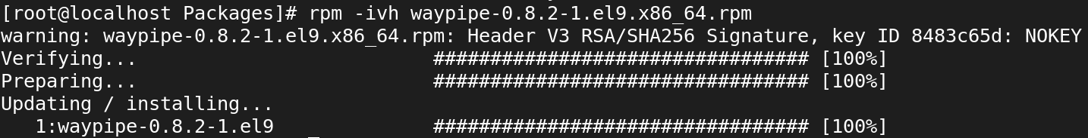

* What command is used to query information about an installed RPM package?

**SYNTAX:**

* rpm -qa
* q 🡪 Query
* a 🡪 queries all installed packages

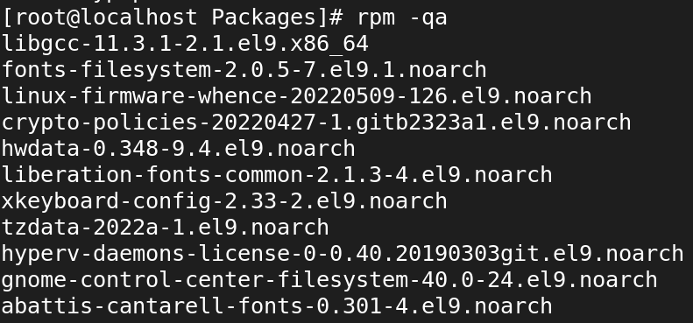

* How can you list all the files installed by an RPM package?

**SYNTAX:**

* rpm -ql httpd

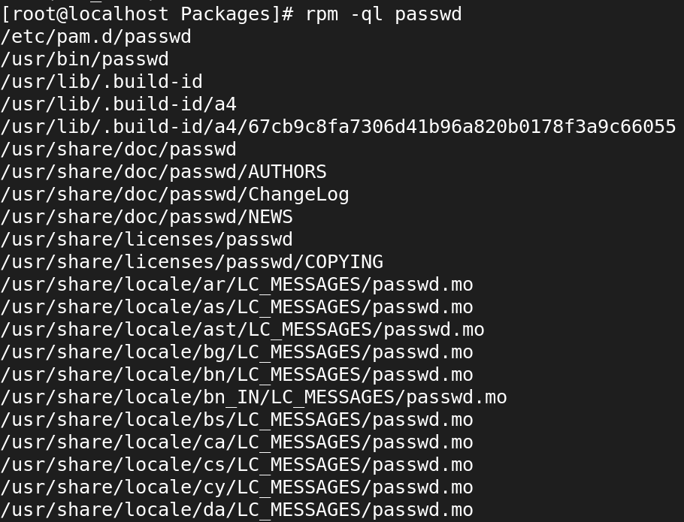

* What is the purpose of the RPM database in Linux?
* **Package Management**: Stores information about installed RPM packages.
* **Dependency Management**: Tracks package dependencies to ensure all required packages are installed.
* **Querying**: Allows users to find details about installed packages and their files.
* **Installation and Removal**: Updates the database when packages are added or removed.
* **Verification**: Checks the integrity of installed packages.
* **Rollback**: Facilitates reverting to previous package versions if needed.
* What command is used to upgrade an installed RPM package to a newer version?

Syntax:

rpm -U <package_file.rpm>



* How can you remove an installed RPM package from the system?

**SYNTAX:**

* rpm -evv httpd

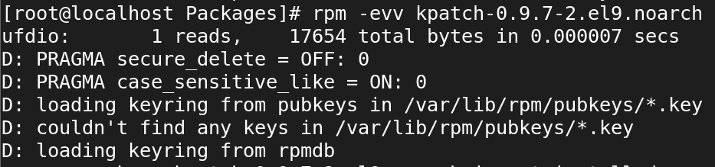

* rpm -evh kpatch-0.9.7-2.el9.noarch

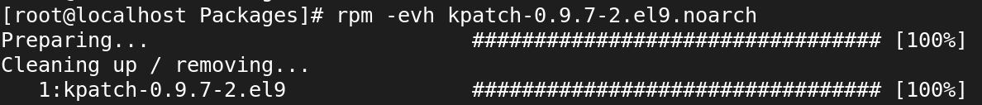

* What is the purpose of dependency resolution in RPM packages?
* **Prevent Installation Errors**: Dependency resolution checks for required packages, preventing installation failures due to missing components.
* **Ensure Compatibility**: It verifies that the correct versions of libraries and dependencies are installed, maintaining software compatibility and stability.
* **Automate Installations**: Tools like yum and dnf automatically handle dependency resolution, simplifying the installation process for users.
* **Improve System Integrity**: By ensuring that all dependencies are met, it helps maintain the integrity and functionality of the system.
* How can you list the dependencies of an RPM package?

**SYNTAX:**

* rpm -qpR waypipe-0.8.2-1.el9.x86_64.rpm
* q 🡪 Query a package
* p 🡪 List capabilities this package provides.
* R 🡪 List capabilities on which this package depends.

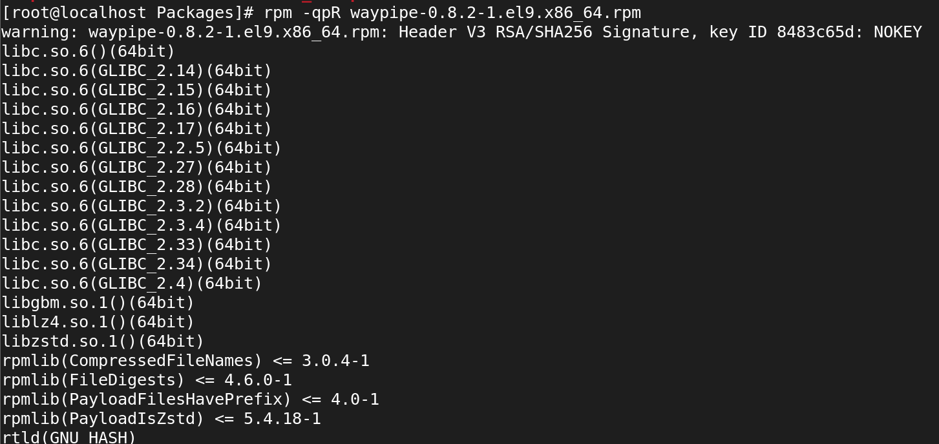

**15. Yum in Linux:**

* What is Yum and what is its purpose in Linux?
* YUM (Yellowdog Updater, Modified) is a package management tool for RPM-based Linux distributions like Red Hat, CentOS, and Fedora. Its main purposes are:

1. **Package Management**: Simplifies installing, updating, and removing software.
2. **Dependency Resolution**: Automatically manages package dependencies.
3. **Repository Management**: Works with online repositories to download and install packages.
4. **System Updates**: Checks for and installs updates for installed packages.
5. **Configuration**: Allows easy configuration of repositories.
6. **Querying**: Enables users to search for available and installed packages.

* How can you install a package using Yum in Linux?

Syntax:

* yum install zip

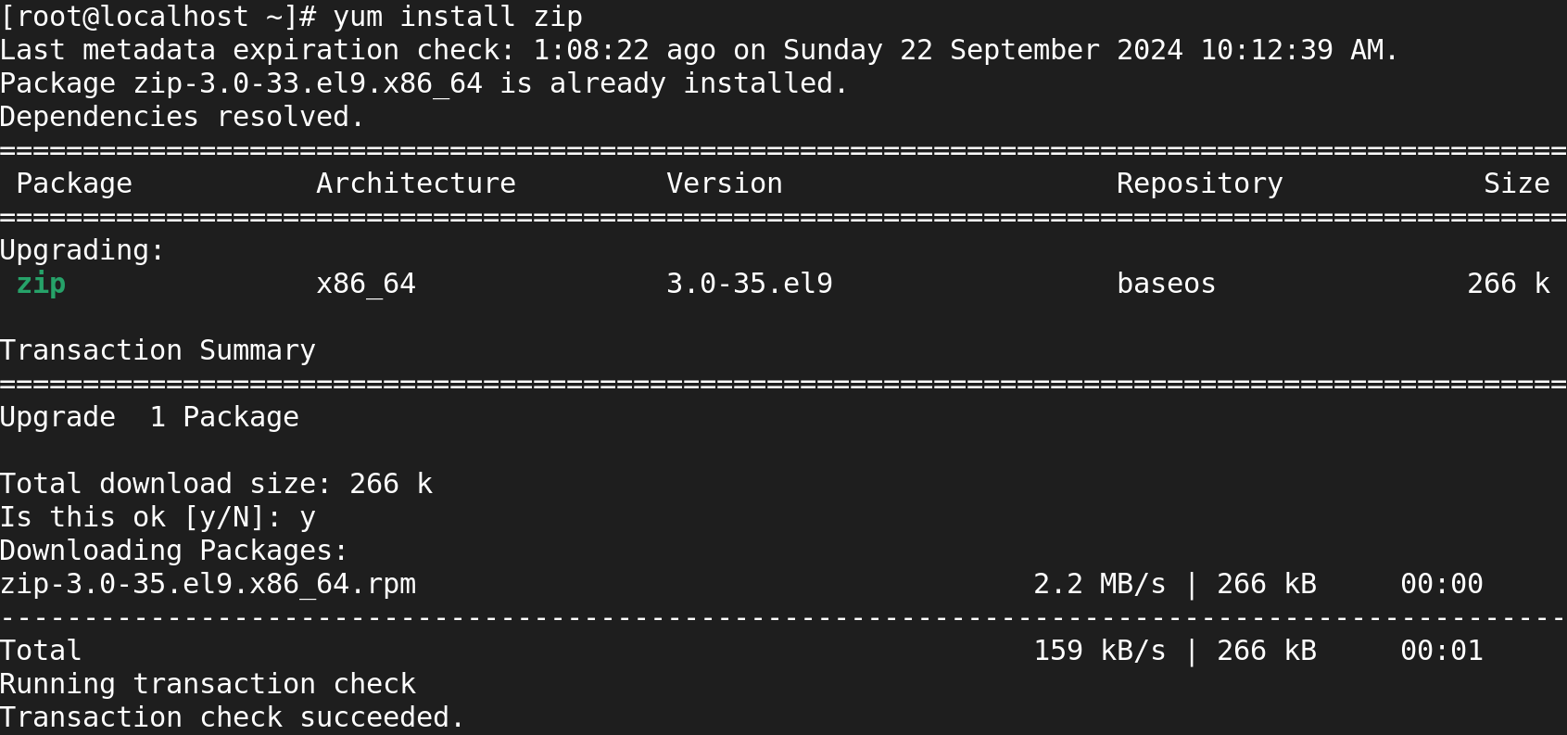

* What command is used to search for packages using Yum?

Syntax:

* yum search coreutils

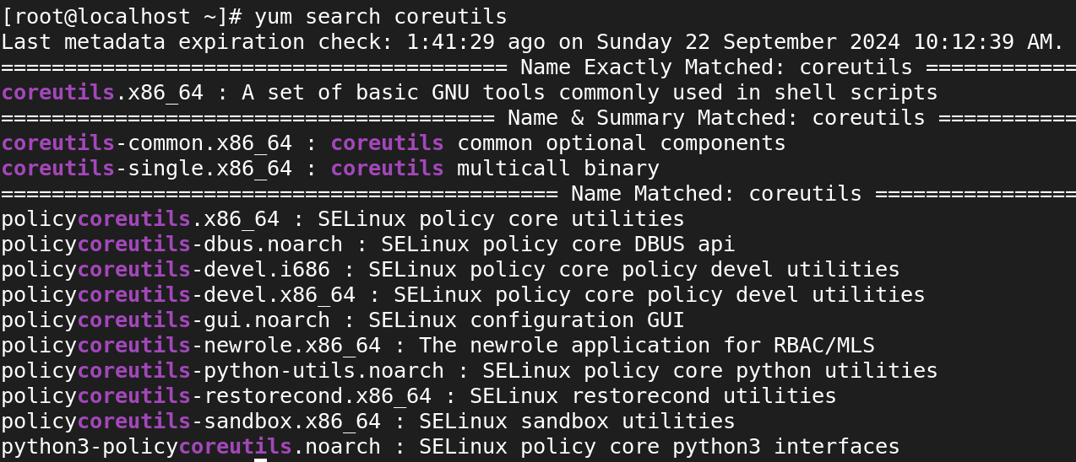

* How can you update all installed packages using Yum?

Syntax:

* yum update

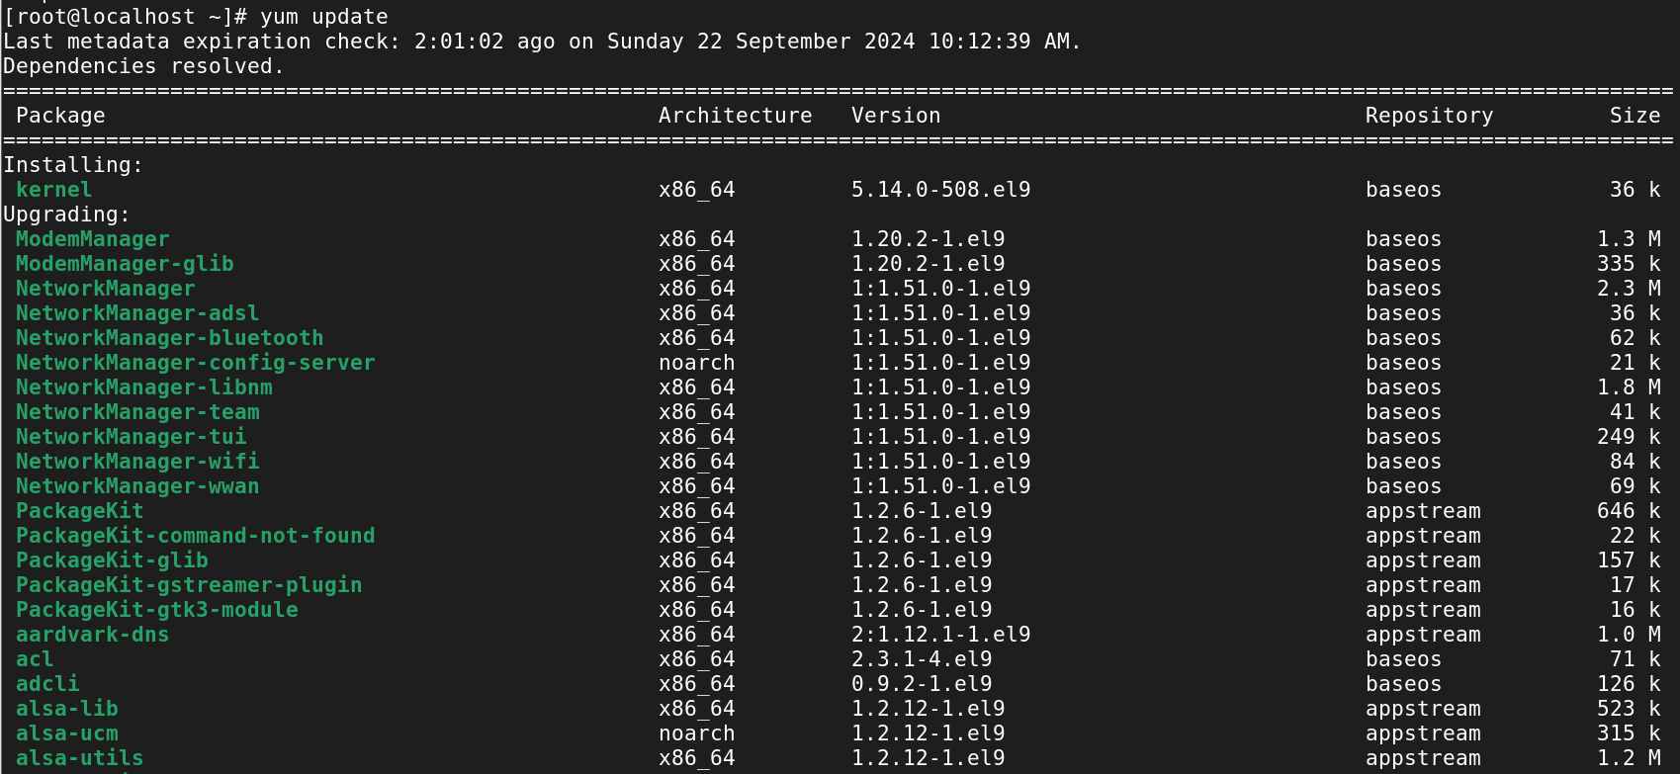

* What is the purpose of repositories in Yum?
* **Package Storage**: Centralized locations for software packages and metadata.
* **Dependency Management**: Ensures all required packages are available for installation.
* **Version Control**: Maintains multiple versions of software for users to install or upgrade.
* **Security and Updates**: Distributes updates and security patches to keep systems secure.
* **Consistency**: Provides tested and compatible software for specific distributions.
* **Configuration Management**: Allows easy configuration of multiple repositories for software sourcing.
* How can you enable or disable a repository in Yum?

**Enable repository:**

* yum-config-manager –enable appstream-debug

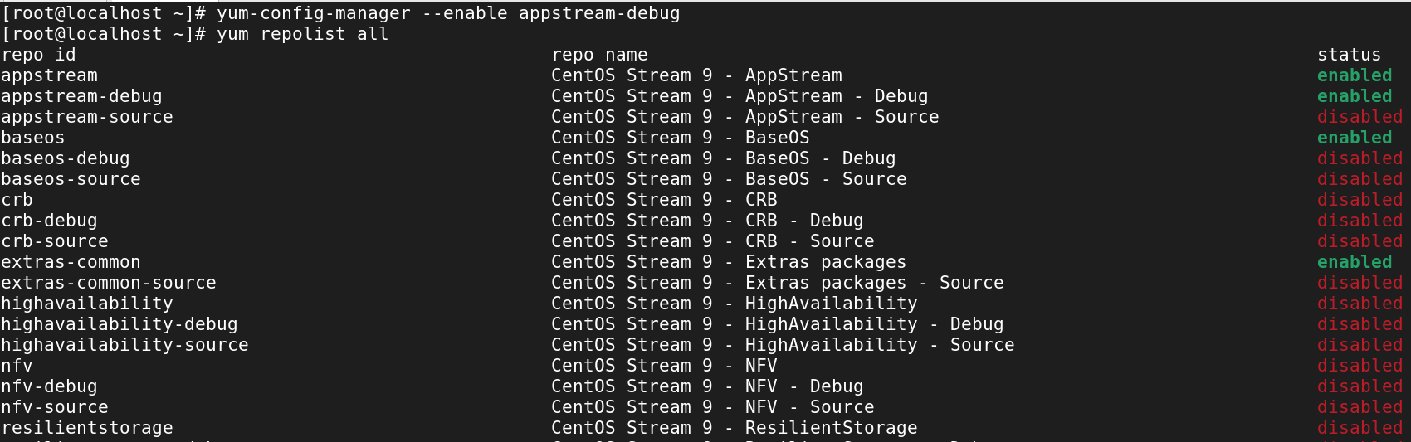

**Disable repository:**

* yum-config-manager –disable appstream-debug

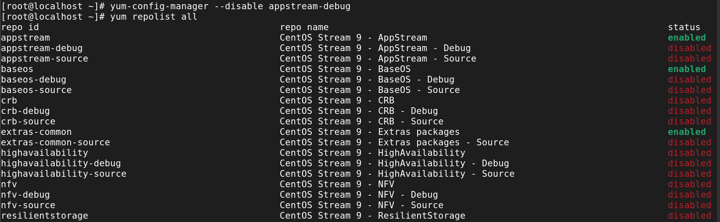

* What command is used to list the enabled repositories in Yum?

Syntax:

* yum repolist

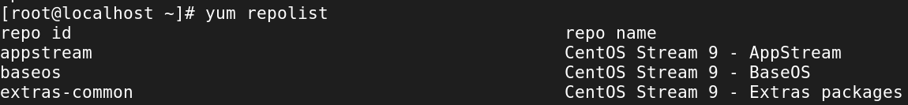

* How can you install a specific version of a package using Yum?

Syntax:

* **yum install httpd-1.2.3-4.el7**

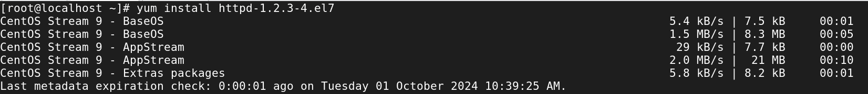

* What is the difference between Yum and RPM?

**Yum**:

* Yum is a **package manager** that handles the installation, update, and removal of packages in a system. It also resolves dependencies automatically, ensuring all required packages are installed.
* It fetches packages from configured repositories and installs them along with their dependencies.
* Suitable for maintaining a consistent package environment on a system.

**RPM**:

* RPM is a **lower-level tool** used for managing individual packages. It allows you to install, upgrade, query, verify, and remove packages.
* It doesn’t handle dependencies automatically. If a package has dependencies, you need to manually resolve and install them.
* It is often used for inspecting, building, or directly installing .rpm package files.
* How can you list the dependencies of a package using Yum?

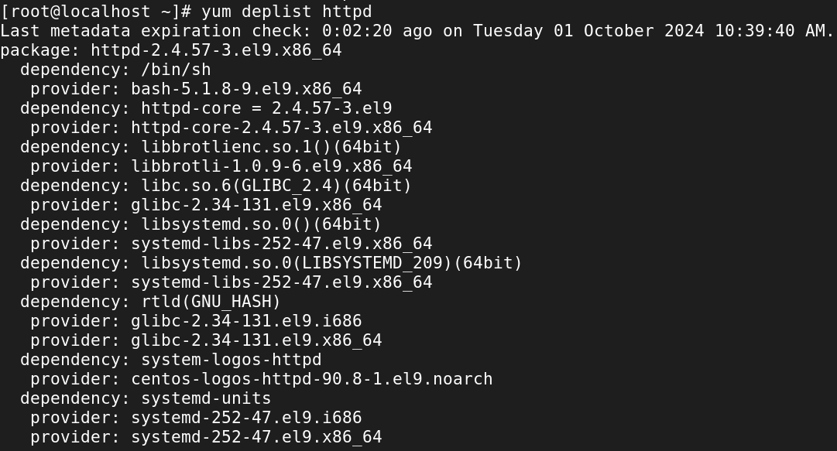

* How can you install a package group using Yum?

Syntax:

* yum groupinstall "group-name"

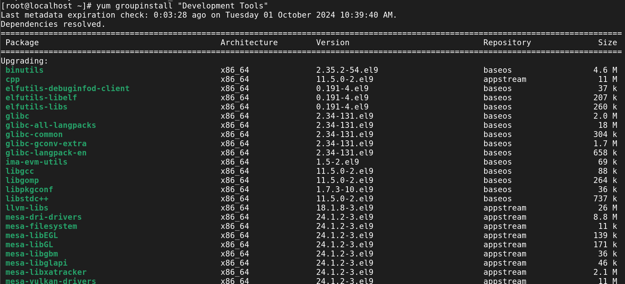

**Yum repositories in Linux**

* What is a Yum repository in Linux?
* A **Yum repository** (short for Yellowdog Updater, Modified repository) in Linux is a central storage location that hosts packages and their metadata, which are used for software management and installation.
* It is essentially a collection of software packages (RPM files) and information about those packages, allowing yum to retrieve, install, update, or remove software on your system.
* How can you configure a custom Yum repository in Linux?
* cd /etc/yum.repos.d
* vi <file>

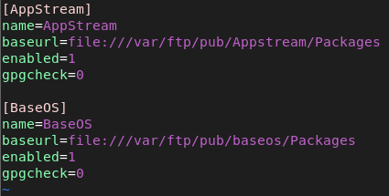

* What is the purpose of the baseurl directive in a Yum repository configuration?

**Definition**:

* The baseurl is a mandatory configuration parameter in a .repo file that points to the repository’s root directory.

**Supported Protocols**:

* It can point to a repository hosted on a web server, FTP server, or a local file system. The supported protocols are:
* **HTTP/HTTPS**: baseurl=http://mirror.centos.org/centos/7/os/x86_64/
* **FTP**: Example: baseurl=ftp://ftp.example.com/repo/
* **File**: Example: baseurl=file:///mnt/localrepo/
* How can you remove a Yum repository from the system?
* rm -rf /etc/yum.repos.d
* What is the role of the yum.repos.d directory in Yum repositories?
* The /etc/yum.repos.d/ directory serves as the main directory for managing repositories on a system.
* Without this directory and the .repo files it contains, Yum would not know where to look for packages.
* It allows for easy addition, removal, and configuration of repositories, making it a central place for repository management and maintenance.
* What command is used to synchronize the metadata of a Yum repository?

**yum makecache**:

* This command downloads and caches the metadata of enabled repositories, ensuring that yum has the latest information about the available packages, their versions, and dependencies.
* The metadata includes information such as package lists, dependencies, and repository configuration.
* Having this data cached allows for faster searches and queries since Yum doesn't have to retrieve metadata from the repositories every time.

Syntax:

* yum makecache
* What are some common Yum repository management commands in Linux?

**List Enabled Repositories**:

* yum repolist

**Add a New Repository**:

* yum-config-manager --add-repo http://example.com/repo/custom.repo

**Update Repository Metadata**:

* yum makecache

**Install a Package from Repositories**:

* yum install <package-name>

**Clean Up Cache**:

* Yum clean-all

**16. SSH**

* what is ssh?
* SSH, also known as **Secure Shell or Secure Socket Shell**, is a cryptographic network protocol that gives users, particularly system administrators, a secure way to access a computer over an unsecured network.
* It’s that provide secure encrypted communications between two untrusted hosts over an insecure network.
* port number of SSH?
* default port 🡪 22
* Is it possible to change ssh port number?
* Yes,we change port number in ssh configuration file.
* vi /etc/ssh/sshd_config
* Write command to login remote machine in terminal?

Syntax:

**ssh root@192.168.45.130**

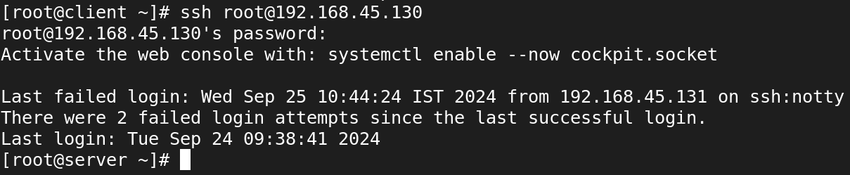

* Write command to login local machine in terminal?

Syntax:

* su - user1

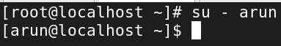

* ssh configuration file location?

**SSH Client Configuration**

* **Location**: ~/.ssh/config
* **Description**: This file contains configuration settings for the SSH client, allowing users to customize their SSH connections. You can specify options such as host aliases, user names, ports, and identity files for specific remote hosts.

**SSH Server Configuration**

* **Location**: /etc/ssh/sshd_config
* **Description**: This file contains the configuration settings for the SSH server (sshd). It controls how the SSH server behaves and manages security settings, authentication methods, and more.
* configure SSH key based authentication? write path of key file location? server1-user:admin1 to server2-user:admin1
* generate key: # ssh-keygen

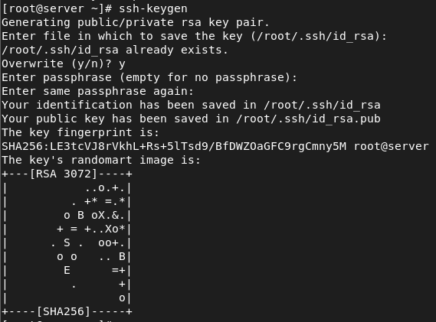

**Path of key file location:**

* /root/.ssh



* Copy keys to client: # ssh-copy-id root@<server ip>

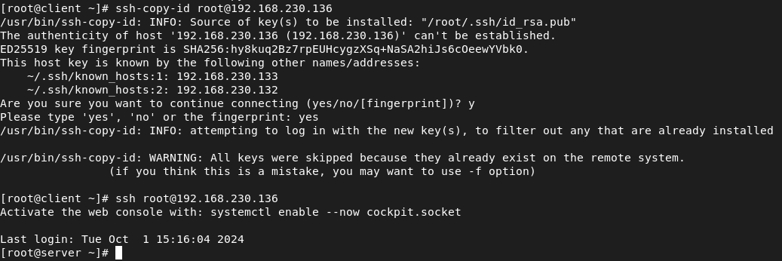

* what is the command to generate the ssh key?

**Syntax:**

* ssh-keygen

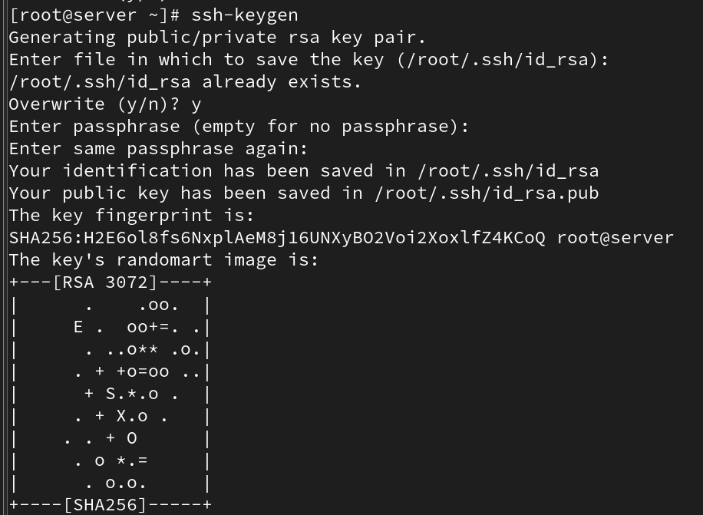

* what is the command to copy the keys to remote machine?

Syntax:

* sh-copy-id root@192.168.190.128

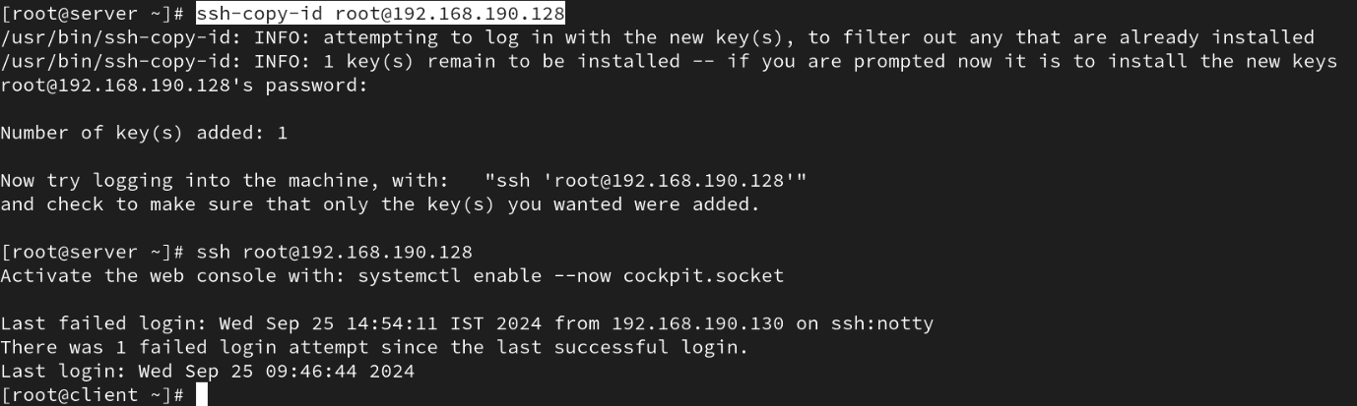

* when you generate the key what are files will be create?

**Private Key**

* **File Name**: id_rsa (or another name if specified)
* **Location**: ~/.ssh/id_rsa
* **Description**: This file contains the private key, which should be kept secure and never shared with anyone. It is used to authenticate your identity when connecting to an SSH server. The private key must be protected from unauthorized access.

**Public Key**

* **File Name**: id_rsa.pub (or another name with .pub extension if specified)
* **Location**: ~/.ssh/id_rsa.pub
* **Description**: This file contains the public key, which can be shared with remote SSH servers to allow authentication. You will copy the contents of this file to the authorized keys file on the remote server to enable key-based authentication.
* what is the ssh daemon name?
* **sshd** is the server-side component of the SSH protocol, responsible for handling incoming SSH connections, managing user authentication, and providing secure access to the system over a network.
* It listens for connection requests on a specified port (default is port **22**) and initiates secure communication sessions with SSH clients.
* write ssh service-related commands which you know?
* ssh
* scp
* ssh-keygen
* systemctl start,stop,enable,disable,restart, reload sshd
* ssh-copy-id
* Disable ssh root login?

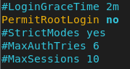

* How to disable password-based authentication?
* In /etc/ssh/sshd_config file,we can disable the password based authentication.

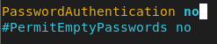

* Allow ssh access to particular user? (user1, user2, user3)
* In vi /etc/ssh/sshd_config file,we five access to particular users.
* Change ssh port number 4044 and try to ssh login.

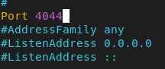

* How to start, stop, restart, check the status of ssh service?

### **Start the SSH Service**

* To start the SSH service (sshd)
* systemctl start sshd



### **Stop the SSH Service**

* To stop the SSH service
* systemctl stop sshd



### **Restart the SSH Service**

* To restart the SSH service, which is useful after making configuration changes
* systemctl restart sshd



### **Check the Status of the SSH Service**

* To check the current status of the SSH service, use:
* systemctl status sshd

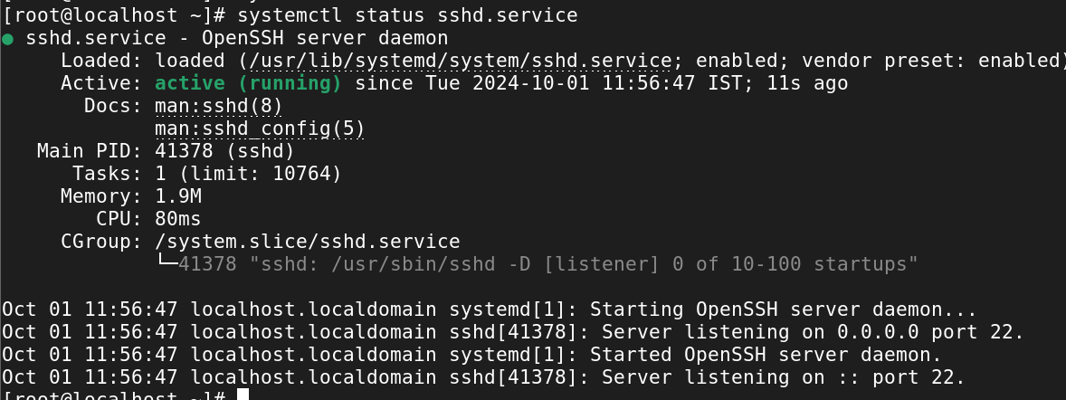

* How to start the ssh service permanently?

Syntax:

* systemctl enable --now sshd

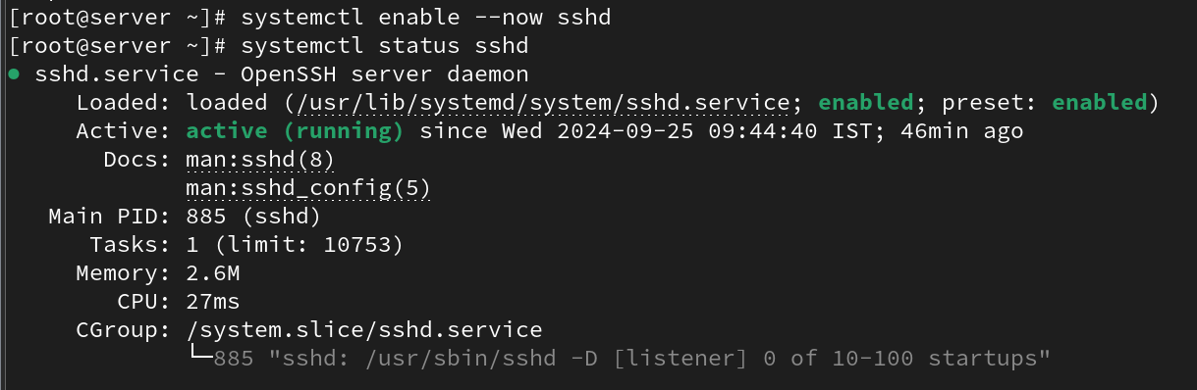

* How to stop the ssh service permanently?

Syntax:

* systemctl disable --now sshd

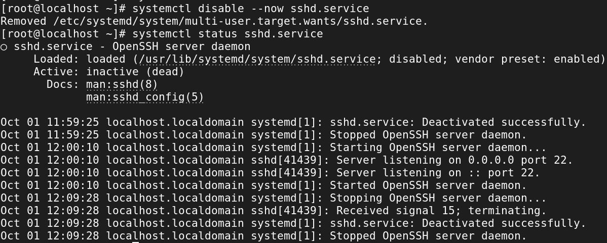

**17. Analyzing and storing logs in Linux**

* What is the purpose of log files in Linux?
* Log files are essential for maintaining, troubleshooting, securing, and optimizing Linux systems.
* They provide a detailed record of system activity and serve as a critical tool for system administrators in managing and safeguarding their environments.
* Proper management and analysis of log files can significantly enhance the reliability and security of Linux systems.
* How can you view the contents of a log file in Linux?
* What command is used to search for specific keywords or patterns within a log file?
* How can you filter log entries based on specific criteria using the grep command?
* What is the purpose of log rotation in Linux?
* **Prevent Disk Space Issues**: Regularly archives or deletes older logs to free up disk space.
* **Improve System Performance**: Smaller log files are easier to access and manage, enhancing performance.
* **Simplify Log Management**: Facilitates the organization and archiving of logs for easier access and analysis.
* **Facilitate Analysis and Troubleshooting**: Creates time-based segments for easier analysis of log data during troubleshooting.
* **Enhance Security and Compliance**: Maintains an audit trail and limits the exposure of sensitive information in logs.
* How can you configure log rotation for a specific log file?
* What is the significance of log levels in log files?
* **Prioritization**: Indicate the severity of events, helping users focus on critical issues first.
* **Troubleshooting**: Allow filtering of logs to quickly identify and resolve problems.
* **Readability**: Enhance organization, making it easier to scan for relevant information.
* **Customizable Logging**: Enable different logging levels for various environments (e.g., DEBUG for development, ERROR for production).
* **Compliance**: Help meet regulatory requirements by documenting important actions and errors.
* How can you analyse logs for errors and warnings using regular expressions?
* What are some commonly used log files in Linux?
* **/var/log/messages**: General system messages and logs useful for troubleshooting.
* **/var/log/secure**: Authentication-related messages, including login attempts, important for security auditing.
* **/var/log/boot.log**: Logs from the boot process, useful for troubleshooting startup issues.
* **/var/log/mail.log**: Logs for mail servers, useful for diagnosing email-related issues.
* **/var/log/cron.log**: Logs related to cron jobs, tracking scheduled tasks.
* **/var/log/dmesg**: Kernel ring buffer messages, useful for diagnosing hardware issues.
* How can you monitor log files in real-time using the tail command?
* What is the purpose of log analysers and monitoring tools in Linux?
* **Centralized Log Management**: Aggregate logs from multiple sources for easier management.
* **Real-Time Monitoring**: Detect anomalies and alert administrators immediately.
* **Enhanced Troubleshooting**: Simplify issue diagnosis by identifying patterns in logs.
* **Performance Optimization**: Analyze performance-related logs to improve system efficiency.
* **Security Auditing**: Monitor logs for unauthorized access and security threats.
* **Compliance Reporting**: Generate reports to meet regulatory compliance requirements.
* **Data Visualization**: Provide dashboards for visual representation of log data.
* **Historical Analysis**: Analyze long-term trends in system behavior.
* How can you store logs remotely using a centralized logging server?
* **Choose a Logging Solution**: Select a tool like the ELK Stack, Graylog, or Fluentd.
* **Set Up the Central Logging Server**: Install the logging solution on a dedicated server with adequate resources.
* **Install Logging Agents on Client Machines**: Use agents like Filebeat, Fluentd, rsyslog, or Syslog-ng.
* **Configure the Logging Agents**: Point the agents to the central server and specify the log files to monitor.
* **Adjust Firewall Settings**: Open necessary ports on the logging server for log traffic.
* **Test the Configuration**: Start the agents and verify that logs are being received by the server.
* **Set Up Retention Policies**: Configure how long to keep logs to manage storage.
* **Monitor and Alert**: Set up alerts for issues like high log volume or processing errors.
* What is the role of the /var/log directory in Linux?
* The /var/log directory in Linux serves as a central location for logging files generated by the system, applications, and services.
* It plays a crucial role in system administration and troubleshooting by storing logs that help track system activity, errors, warnings, and various other events.

**18. ACL**

* Set a read and write ACL for user bob on the file /home/user1/report.txt.

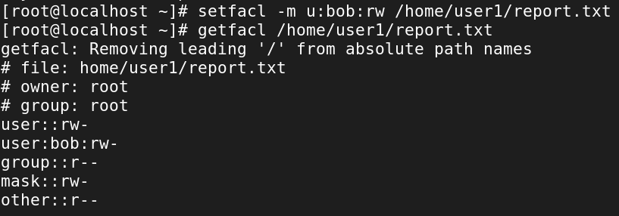

* Remove all ACL entries for the file /var/log/syslog.
* setfacl -b /var/log/syslog



* Grant the group developers read, write, and execute permissions on the directory /home/projects/, including all files and subdirectories.
* Set a default ACL that gives the group marketing read-only access to all new files created in the directory /shared/marketing/.

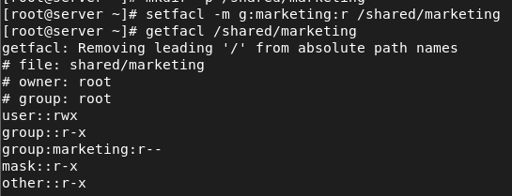

* Check and display all the ACL entries on the file /etc/hosts.
* getfacl /etc/hosts

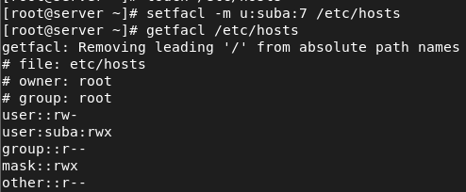

* Set the user alice to have no permissions on the file /home/user2/confidential.txt, even though she belongs to the users group which has permissions.

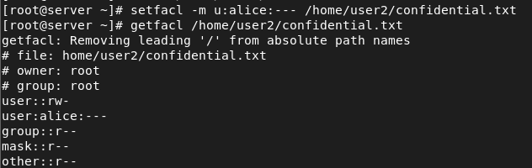

* Grant the user tom execute permission on the directory /scripts/ and all files inside it.
* setfacl -R -m u:tom:x /scripts/

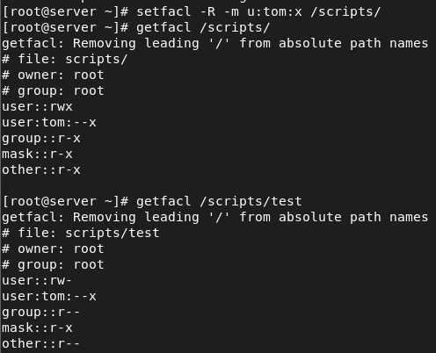

* Modify the ACL of the file /data/project.txt to grant the user susan read and write permissions, but not execute permissions.

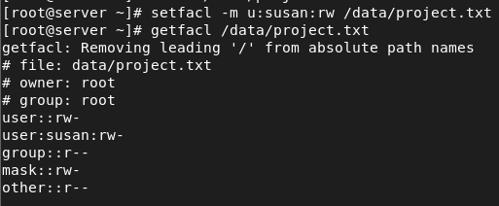

* Set an ACL for the group admin to have full permissions (read, write, execute) on the file /etc/passwd, while keeping the original permissions for other users intact.



* Create an ACL that removes write permissions for the group staff on the file /tmp/notes.txt, but allows the owner to retain full permissions.
* setfacl -m u::7,g:staff:5,o::0 /tmp/notes.txt

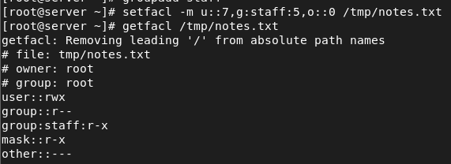

**Network**

* Add additional ethernet card and assign static ip
* vm-settings-add network adapter.

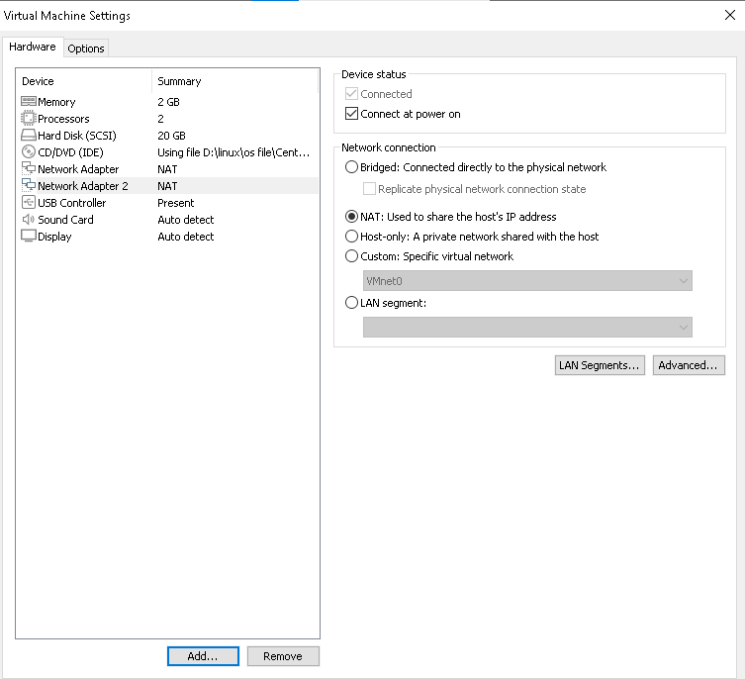

* Add additional ethernet card and assign dynamic ip
* vm-settings-add network adapter



* nmcli device connect <network name>

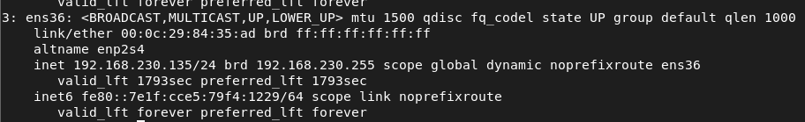

* how to check the server IP also show the current IP details?
* ifconfig
* ip a
* hostname -i
* how to check the server routes also show current route details?
* route -n

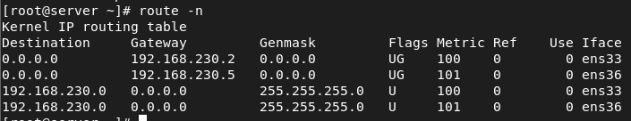

* add two ethernet card ans assignee one ip?

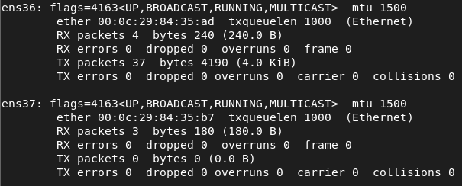

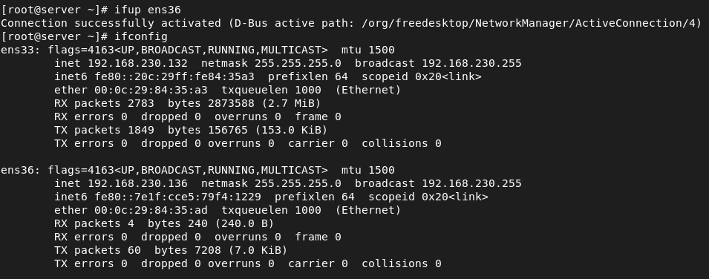

* assign two ip address for one Ethernet card?
* ip addr add <ip> dev ens



* ip addr show ens

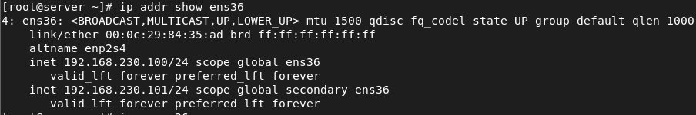

* how to check the server hostname
* hostname

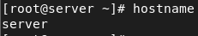

* hostnamectl

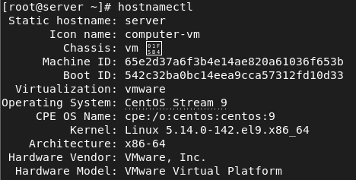

* cat /etc/hostname

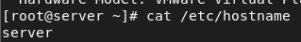

* change server hostname as server.glotechcorp.com permanently
* hostnamectl set-hostname <name>

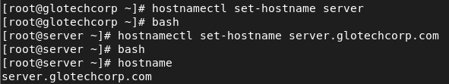

**Find**

* How would you use the `find` command to search for all files with the `.txt` extension in the `/home` directory?
* find /home -type f -name ‘*.txt’

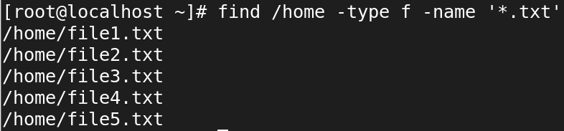

* Write a command using `find` to search for files larger than 100MB in the `/var` directory.
* find /var -type f -size 100M



* Use `find` to locate all files in the `/etc` directory that were modified within the last 7 days.
* find /etc -mtime -7

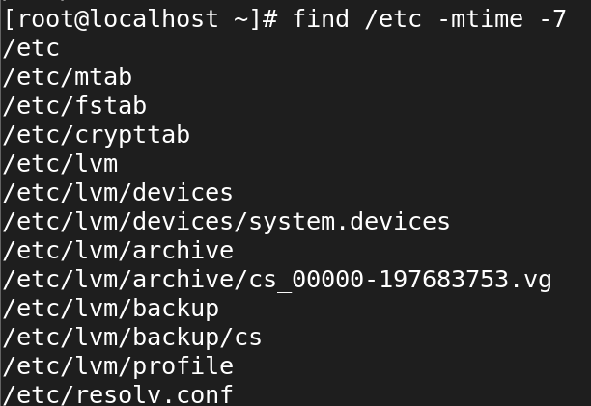

* How can you use `find` to search for files owned by a specific user, for example, `user1`, in the `/home` directory?
* Find all symbolic links within the `/usr` directory using the `find` command.
* find /usr -type l

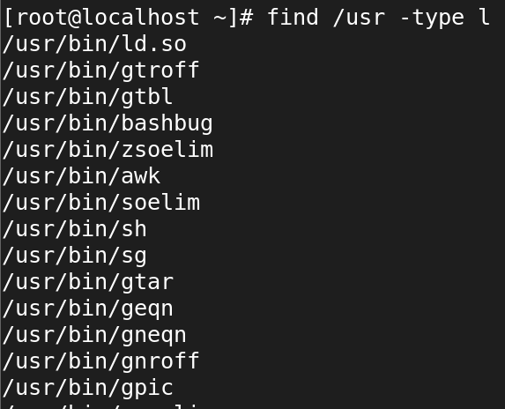

* Write a `find` command to delete all `.log` files in the `/tmp` directory.
* find /temp -type f -name ‘*.log’ -exec rm -rf {} \;



* How would you use the `find` command to locate files with the permissions `644` within `/etc`?
* find /etc -type f -perm 644

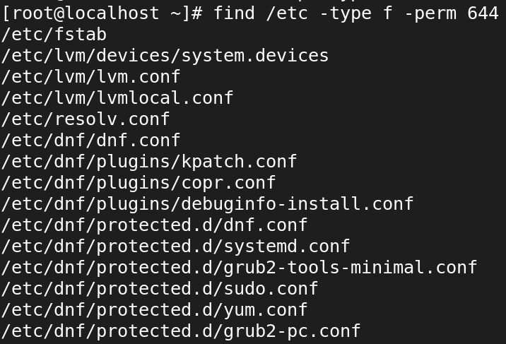

* Use the `find` command to locate all files named `index.html` starting from the root directory (`/`).
* find / -type f -name ‘index.html’

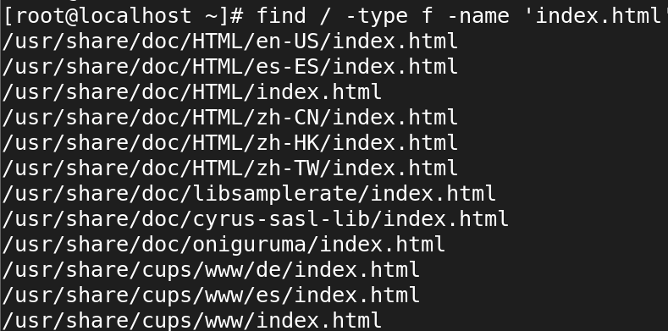

* Write a command using `find` to search for directories (not files) named `backup` within the `/var` directory.
* find /var -type d -name ‘backup’



* How would you find all empty files within the `/home/user/Documents` directory using `find`?
* find /home/user/Documents -type f -empty



**LOCATE**

* 1. How would you use the `locate` command to find all files containing the name `bashrc`?

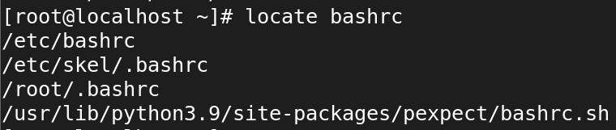

* 2. Write a `locate` command to search for files with the `.conf` extension on your system.

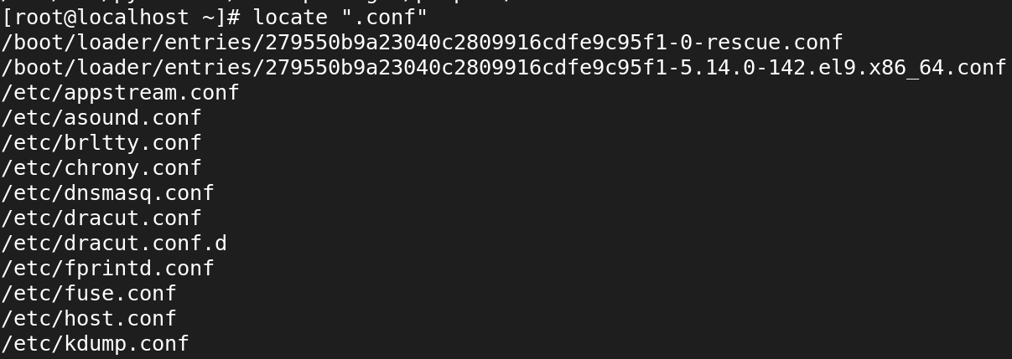

* 3. How can you use `locate` to find all occurrences of a file named `hosts` in the filesystem?
* locate -b ‘/hosts’

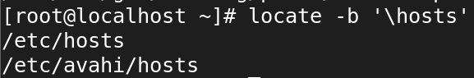

* 4. Use the `locate` command to find directories containing the name `bin` in their path.
* locate */bin

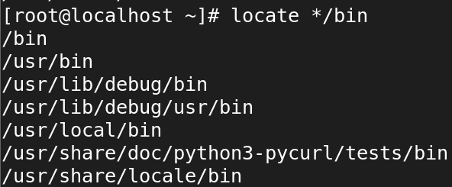

* 5. Write a `locate` command to find files related to the program `ssh`.
* locate ssh

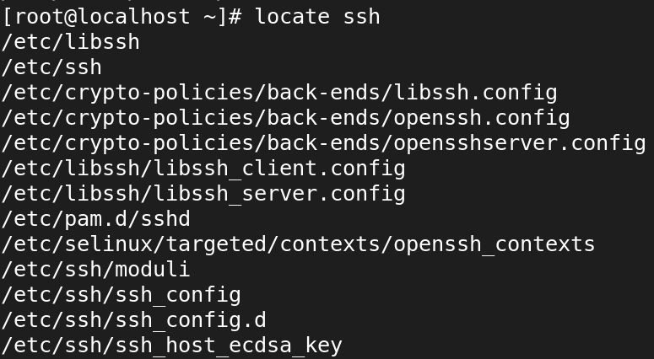

* 6. How would you use `locate` to search for files that were updated in the last 24 hours?
* locate * | xargs -I {} find {} -type f -mtime -1



* 7. Use the `locate` command to find all files and directories containing the word `apache`.
* locate apache

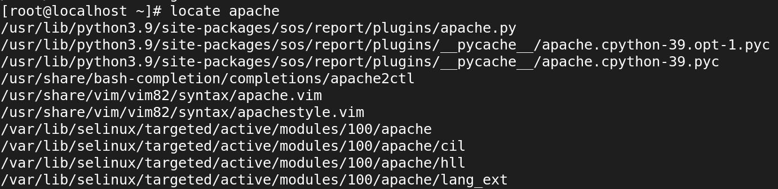

* 8. Write a `locate` command to search for all files in the `/usr` directory that contain the string `lib`.
* locate /usr/lib

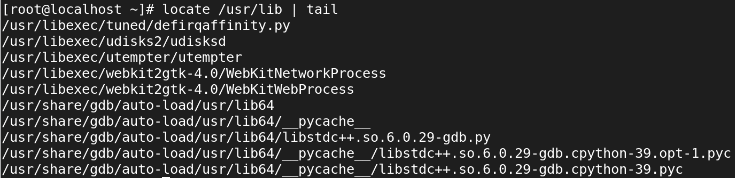

* 9. How can you update the `locate` database manually before performing a search?
* 10. Write a `locate` command to find all files with the `.jpg` extension.
* locate ‘*.jpg’

